*Cairo University*

*Faculty of Computers and Artificial Intelligence*

*Information Systems Department*

Graduation Project Report

FCAI Website (Student’s Section)

Academic Year 2022/2023

**By:**

|  |  |
| --- | --- |
| 20190084 | Arwa Ahmed Walaa |
| 20190153 | Gehad Akram Kamel Ahmed |
| 20190234 | Sara Mohamed Ali Salem |
| 20190233 | Sarah Essam Kamal Mahmoud |
| 20190267 | Shimaa Reda Saeed |

**Under the Supervisors of:**

Assoc. Prof. Iman Mohamed Atef Helal

Eng. Ahmed Mohamed Galal

*Department of Information Systems, Faculty of Computers and Artificial Intelligence, Cairo University, Egypt 2023*

# Abstract

Ecom is a website for FCAI students and faculty. Students can register for courses, view their grades and exam halls, get to know the schedule, and more. Professors and teaching assistants can view the number of students registered in every course, fill in attendance sheets, and more. In this project, we are going to update the website of Ecom to make it easier to deal with. We will add new features that make the website more useful to its users, more familiar, and easier to use.

# Table of Contents

Abstract 2

Chapter 1 Introduction 7

1.1 Background and Motivation 7

1.2 Problem Statement 7

1.3 Objectives 7

1.4 Project Scope and Limitations 8

1.5 Project Stakeholders 9

1.6 Project Methodology 9

1.7 Technologies and Tools 10

1.8 Project Plan (Gantt Chart) 10

1.9 Project Report Outline 10

Chapter 2 Market and Literature Survey 11

2.1 SWOT Analysis 11

2.2 Comparison With Competitors 12

Chapter 3 Analysis and Design 14

3.1 User Stories 14

3.1.1 Student User Stories 14

3.1.2 Professor and TA User Stories 14

3.1.3 Student Affairs User Stories 15

3.1.4 Admin User Stories 15

3.2 Use Case Diagram 16

3.3 Use Case Descriptions 18

3.3.1 Register Course 18

3.3.2 Push Notification 19

3.3.3 View Profile 20

3.3.4 Register Graduation Project 21

3.3.5 Evaluate Course (Student’s Side) 22

3.3.6 Chat 23

3.3.7 View Office Hours and Location 24

3.3.8 View Announcements 25

3.3.9 Report Statistics (About Student Results) 26

3.3.10 View Top 50 27

3.3.11 View Student’s Data 28

3.3.12 View a Schedule of (All Courses and All Levels) to the Professor and TAs 29

3.3.13 View Course Evaluation (Done by Students Anonymously) 30

3.3.14 Download Schedule or Bylaw 31

3.3.15 Search 32

3.3.16 Add Course/Group Preferences 33

3.3.17 Login User 34

3.3.18 Add Student 35

3.3.19 Add Announcement 36

3.3.20 Add Schedule File 37

3.4 Class Diagram 38

3.5 Sequence Diagrams 39

3.5.1 Register Course 39

3.5.2 Internal Chat 40

3.5.3 View Office Hours 41

3.5.4 View Schedule 41

3.6 Web Persona 42

3.6.1 Student 42

3.6.2 Professor 43

3.6.3 Teaching Assistant 44

3.6.4 Student Affairs Employee 45

3.6.5 Admin 46

Chapter 4 Design and Implementation 47

4.1 System Prototype Screens 47

# List of Figures

Figure 1. Gantt Chart of Project Timeline 10

Figure 2. Use Case Diagram for Professore and TA 16

Figure 3. Use Case Diagram for Student and Admin 17

Figure 4. Detailed Class Diagram 38

Figure 5. Sequence Diagram for Register Course 39

Figure 6. Sequence Diagram for Internal Chat Between Professors or TAs and Students 40

Figure 7. Sequence Diagram for Student to View Office Hours of a Professor or TA 41

Figure 8. Sequence Diagram for Student to View His/Her Schedule 41

Figure 9. Student Persona 42

Figure 10. Professor Persona 43

Figure 11. TA Persona 44

Figure 12. Student Affairs Employee Persona 45

Figure 13. Admin Persona 46

Figure 14. Student Home - Not Logged in Screen 47

Figure 15. Announcements - Not Logged in Screen 48

Figure 16. Download Schedule or Bylaw - Not Logged in Screen 49

Figure 17. Log in Screen 50

Figure 18. Forgot Password Screen 50

Figure 19. Reset Password Screen 51

Figure 20. Home Screen 51

Figure 21. View Profile Screen 52

Figure 22. Edit Profile Screen 53

Figure 23. Change Password Screen 54

Figure 24. Announcements Screen 55

Figure 25. Top 50 Screen 55

Figure 26. Download Schedules or Bylaw Screen 56

Figure 27. Chat Screen 57

Figure 28. Office Hours Screen 57

Figure 29. Registered Courses Screen 58

Figure 30. Grades Screen 58

Figure 31. Register New Course Screen 59

Figure 32. New Course Added Screen 60

Figure 33. Select Groups Screen 60

Figure 34. Choose Course to Evaluate Screen 61

Figure 35. Evaluate Course Screen 61

Figure 36. Specialization Program Selection 62

Figure 37. Register Graduation Project Screen 63

Figure 38. My Schedule Screen 64

Figure 39. Exam Halls Screen 65

# Introduction

The main idea of this project is to make a website for the students and staff (Professors and Teaching Assistants) of the faculty of Computer Science and Artificial Intelligence of Cairo University.

## Background and Motivation

The current webapp has several problems; it crashes every term when the students try to register their courses, both students and professors, and TAs have to use several other websites and applications to communicate and share course material, the website isn’t really helpful for professors and Tas, and several other issues. We will try to solve these problems and improve the webapp to be more helpful to the students and the faculty and meet their needs.

## Problem Statement

* Course and group registration always has problems and crashes.
* Graduation project registration is done offline.
* The communication between professors and teaching assistants (TAs) and students.
* The need of notification when there is any news like results, schedule, or registration opens, etc.

## Objectives

* Make notifications when there is any news like results, schedule announcements and updates, or registration open and close dates, etc.
* Do a form for the graduation project like an agreement between the students, supervisor, and responsible TA. The supervisor and TA can either accept or reject the team’s proposal. Updates are reflected accordingly.
* Present a customized schedule to the professors and TAs. Each one can either see a view of their assigned courses, the schedule for the level(s) they are teaching, or the complete schedule.
* Internal. private chat between the students, professors, and TAs to help easier and reliable communication.

## Project Scope and Limitations

|  |  |
| --- | --- |
| **Description** | This webapp will be divided into two sides: Student's side and Faculty's side.  We will add new features such as notifications when registration opens or an event occurs, statistics about student results, add a new section for emails to professors and TAs and over time we can add other features. |
| **Requirements** | **Functional requirements:**  Student's side:   * Push Notifications when registration opens, results of exams are published, there is an announcement, or schedule is released. * Register in a course. * View registered courses, their grades, and exams halls. * Section for emails to professors and TAs (internal chat). * Course Evaluation. * Register graduation project. * View office hours and location (with name of hall).   Faculty side:   * Push notifications whenever the professor or TA is assigned to a course. * View a customized schedule (all courses and all levels) to the Professor and TAs. * Report statistics about student results. * View all students with their (names, GPA, grade in a specific * course the professor is assigned to). * View course feedback done by students without their names. * Download course catalog. * Search by (student/course). * Admin can add course preferences.   Common features:   * View Top 50 (general/department/course). * View the announcements. * View profile   **Non-functional requirements:**  Scalability:   * The website attendance limit must be scalable enough to support 5000 users at a time.   Security:   * Authentication: Users must have accounts to access the website. A security system typically grants access to accounts when users enter the correct username and password. Our system works on the premises that users are granted their usernames and passwords by the admin, so users can’t create accounts. * Authorization: There are several types of users, each has their access rights. * Password generation: if user want to change his password it must be strong.   Usability:   * When they first encounter an interface, users should be able to find their way about easily enough to achieve objectives without relying on outside/expert knowledge.   Performance:   * The front-page load time must be no more than 2 seconds for users that access the website using an LTE mobile connection. |

## Project Stakeholders

* + System Administrator.
  + Students.
  + Professors.
  + Teaching Assistants (TAs).
  + Student Affairs.

## Project Methodology

Iterative Waterfall

Why, because:

* The end goal of our project is clearly defined, and isn’t going to change.
* The stakeholders know exactly what they want (and it isn’t going to change).
* The project is consistent and predictable (i.e., isn’t going to change).
* We are working in a regulated industry that needs extensive project tracking or documentation.

## Technologies and Tools

**Google docs**

For making our documentation together as it supports sharing the file.

**Lucidchart**

For making class diagram, use case diagrams ERD and sequence diagrams.

**Trello**

For dividing work among us and see the progress

**ANGULAR FRAMEWORK**

For developing the front-end.

**LARAVEL FRAMEWORK**

For developing the back-end.

GITHUB (VCS)

For sharing project folder and easier collaboration.

SLACK

To communicate with other teams.

VISUAL STUDIO CODE

For writing and editing code.

## Graphical user interface, application, table, Excel Description automatically generatedProject Plan (Gantt Chart)

Figure 1. Gantt Chart of Project Timeline

## Project Report Outline

This document outline will be as follows:

- Chapter 2 presents the market and literature review of project.

- Chapter 3 presents the analysis and design of the system.

- Chapter 4 presents an in-depth explanation of the implementation of the system and prototype screens.

- Chapter 5 presents the test cases and a project evaluation of the system.

- Chapter 6 concludes the work and lessons learned, then sheds the light to future work.

# Market and Literature Survey

## SWOT Analysis

**STRENGTHS**

* Adding new features that we all missed in the old one.
* This web app will be more interactive than the old one.
* Analysis of students' grades.
* View office hours and location of professors and TAs’ offices.

**WEAKNESSES**

* Not all the team are familiar with the technology that will be used.

**OPPORTUNITIES**

* Replacing the New E-com with the new version on it.
* The web App does not belong only to FCAI-CU and may attract other faculties from universities all over Egypt.

**THREATS**

* The new version may not attract the required audience to get its full features.
* It will not be easy for the faculty to get rid of the current up and running website even though it has issues.

## Comparison With Competitors

|  |  |  |  |  |
| --- | --- | --- | --- | --- |
| Featrue | [BIS](fcba-hu.net/BIS-FMI-Portal/)[1] | AASTMT[2] | [New E-com](http://newecom.fci-cu.edu.eg/" \l "/)[3] | FCAI Website |
| Push notifications | 🗴 | 🗴 | 🗴 | ✔ |
| Register new course | ✔ | ✔ | ✔ | ✔ |
| View Top 50 | 🗴 | 🗴 | ✔ | ✔ |
| View the announcements | ✔ | ✔ | ✔ | ✔ |
| Section for emails to professors and TAs | 🗴 | 🗴 | FCI-CU email | ✔ |
| Course evaluations | ✔ | ✔ | ✔ | ✔ |
| View a schedule to the Professor or TA about all courses assigned to them | ✔ | ✔ | Static view per course or level | ✔ |
| Set statistics about student results | 🗴 | ✔ | 🗴 | ✔ |
| View the total number of students in a specific course the Professor is assigned to | 🗴 | ✔ | 🗴 | ✔ |
| Register graduation project (as a form) | 🗴 | 🗴 | Manual | ✔ |
| Internal chat | 🗴 | ✔ | 🗴 | ✔ |
| View office hours and location | 🗴 | 🗴 | 🗴 | ✔ |
| View profile | ✔ | ✔ | ✔ | ✔ |
| Search by (User/course) | ✔ | ✔ | ✔ | ✔ |
|  |  |  |  |  |
| Admin can add course preferences and group preferences | ✔ | ✔ | Manual adjustment | ✔ |
| Download course catalog | ✔ | ✔ | ✔ | ✔ |
| Request exam remarking | 🗴 | ✔ | ✔ | 🗴 |

# Analysis and Design

## User Stories

### Student User Stories

1. As a student, I want to register for new courses so that I can select which courses I want and select their groups.
2. As a student, I want to receive notifications when registration opens, results of exams are published, there is an announcement, or schedule is released…etc.
3. As a User, I want to view my profile and edit it.
4. As a student, I can register the graduation project and put the idea of it, then select available professors and TAs from his/her department.
5. As a student, I can write my feedback about the content of each course, professors, and TAs.
6. As a student, I want to view top 50 students for each level /department /course.
7. As a student, I want to view my courses and my grade and all the exams for each course.
8. As a student, I want to view the announcements.
9. As a student, I want to be able to contact professors or TAs via chat.
10. As a student, I want to view office hours of professor and TA and the location of his/her office.
11. As a student, I want to download schedule and bylaw files.
12. As a user, I want to be able to login to the updated e-com.

### Professor and TA User Stories

1. As a professor or TA, I want to receive notifications when there is an announcement, or schedule is released or results of feedback from students.
2. As a professor or TA, I can accept or reject the idea of the graduation project.
3. As a professor or TA, I can see the feedback that students write anonymously.
4. As a professor or TA, I want to view top 50 students for each level /department /course.
5. As a professor or TA, I want to view the announcements.
6. As a professor or TA, I want to be able to contact student via chat.
7. As a professor or TA, I want to add office hours and location.
8. As a professor or TA, I want to download schedule and bylaw files.
9. As a professor or TA, I want to search by (student/course).
10. As a professor or TA, I can view statistics about the average grades of each course in each year.
11. As a professor or TA, I can view students’ names, GPAs, grades in a specific course that the professor/TA is assigned to.
12. As a professor, I want to view all students with their (names, GPA, grade in a specific course I assigned to).
13. As a User, I want to view my profile and edit it.

### Student Affairs User Stories

1. As a student affairs employee, I want to add and update student accounts.
2. As a student affairs employee, I want to view all students’ data.
3. As a student affairs employee, I want to search by student.
4. As a User, I want to view my profile and edit it.
5. As a student affairs employee, I want to add announcements.
6. As a student affairs employee, I want to add schedule.

### Admin User Stories

1. As a system admin, I want to add and update accounts for all other users.
2. As a system admin, I want to view information about all users.
3. As a system admin, I want to search users by student/professor/TA/student affairs.
4. As a system admin, I want to add announcements.
5. As a system admin, I want to add schedule.
6. As a system admin, I want to assign a specific professor or TA for a specific course.

## Use Case Diagram

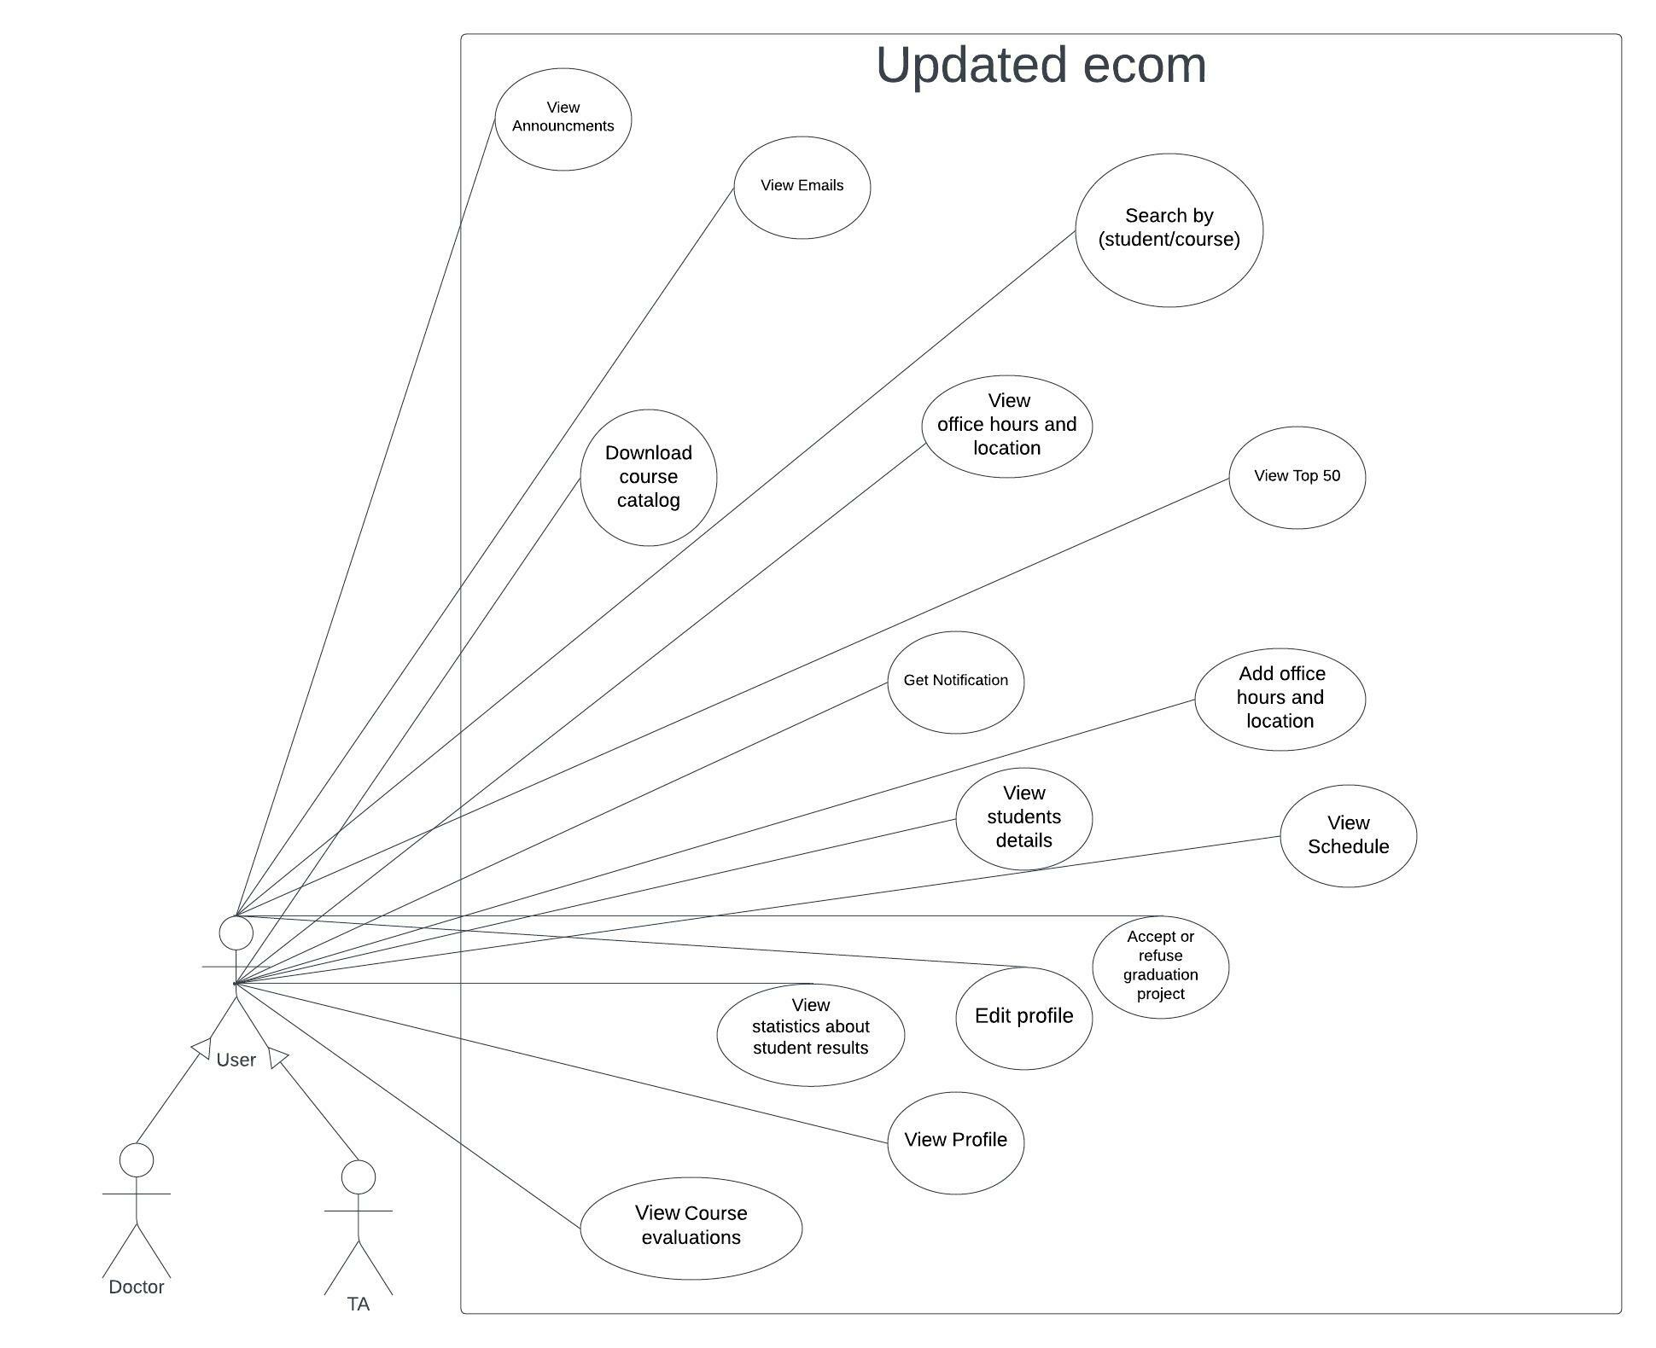

Figure 2. Use Case Diagram for Professore and TA

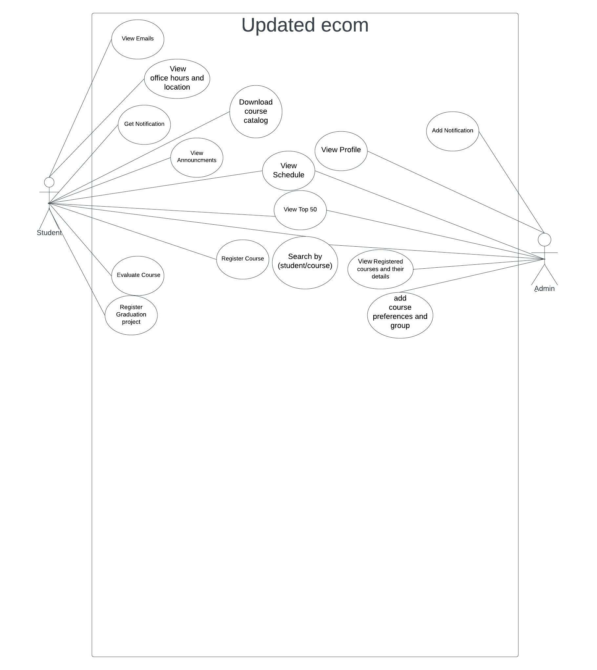

Figure 3. Use Case Diagram for Student and Admin

## Use Case Descriptions

### Register Course

|  |  |  |
| --- | --- | --- |
| Use case name | Register Course | |
| Scenario | When the student receives a notification that the registration is opened the student enters to select his courses and their groups. | |
| Triggering event | When the registration opens. | |
| Brief description | When the student receives a notification that the registration is opened the student enters and shows a list of available courses and then selects his courses and their groups. | |
| Actors | Student | |
| Related use cases | Login User | |
| Stakeholders | Student, Student Affairs, Professor | |
| Preconditions | Students must have an existing account. | |
| Postconditions | Both the related courses and their groups are updated. | |
|  | **Actor** | **System** |
| Flow of activities | 1. The student opens his/her registration page.    2. The student selects his/her courses.    3. The student selects his/her groups. | 1.1. System displays all available courses for this student.    2.1. System checks the limit of credit hours of this user.  3.1. System assigns to a group.    3.2. System returns the schedule. |
| Exception conditions | 2.1 Students reach the minimum or maximum credit hours’ limit.  3.1 There are conflict between the groups or courses. | |

### Push Notification

|  |  |  |
| --- | --- | --- |
| Use case name | Push Notification | |
| Scenario | When the Professor or Student Affairs opens the registration, publishes results of exams, schedule is released or there is an announcement. | |
| Triggering event | When there is new news about results, schedule, or registration. | |
| Brief description | When the registration opens, there is an announcement or the schedule is released, A notification will be sent to students and also will be sent to the professor and TA if the results of feedback of the students are ready or there is an announcement, or the schedule is released. | |
| Actors | Student Affairs | |
| Related use cases | Login User | |
| Stakeholders | Professor, Student Affairs. | |
| Preconditions | Student Affairs must upload the schedule, results or open the registration. | |
| Postconditions | Students, Professors, or TAs go to the site and follow the notification. | |
|  | **Actor** | **System** |
| Flow of activities | 1. The Student Affairs upload the schedule, results or open the registration.  2. The TA, Professor, and student received the notification. | 1.1. System push notification to TA, Professor, and student. |
| Exception conditions | 1.1. Student, professor, or TA doesn't activate the  notification feature. | |

### View Profile

|  |  |  |
| --- | --- | --- |
| Use case name | View Profile | |
| Scenario | User could see his/her profile. | |
| Triggering event | When the user wants to check his/her information and edit it if he/she wants. | |
| Brief description | When the registration opens or the schedule is released, there is an announcement. A notification will be sent to students as well as the professor and TA if the results of feedback of the students are ready or there is an announcement, or the schedule is released. | |
| Actors | Student, professor, and TA | |
| Related use cases | Login User | |
| Stakeholders | Student, professor, TA, and student affairs. | |
| Preconditions | User must have an existing account | |
| Postconditions | --- | |
| Flow of activities | **Actor** | **system** |
| 1. User open his /her profile | 1.1 System display User information |
| Exception conditions | --- | |

### Register Graduation Project

|  |  |  |
| --- | --- | --- |
| Use case name | Register Graduation Project | |
| Scenario | When the registration of the graduation project opens, the student can register the graduation project and put the idea of it, then select from available professors and TAs from his/her department. | |
| Triggering event | When the registration of the graduation project opens. | |
| Brief description | When the student receives a notification that the registration is opened the student enters the project idea then selects from available professors and TAs from his/her department. | |
| Actors | Student, Professor, and TA | |
| Related use cases | Login User and Get Notification. | |
| Stakeholders | Student, professor, TA, and student affairs. | |
| Preconditions | Students must have an existing account. | |
| Postconditions | The student will get a reply from the professor or TA. | |
| Flow of activities | **Actor** | **System** |
| 1. The student sends a description about the graduation project to the professor.    2.Professor accepts that team.    3. The student could view the acceptance. | 1.1. System sends it to the Professor.    2.1. System sends the acceptance to the team. |
| Exception conditions | 2. Professor refuses that team. | |

### Evaluate Course (Student’s Side)

|  |  |  |
| --- | --- | --- |
| Use case name | Evaluate Course (Student’s Side) | |
| Scenario | When the student receives an announcement about the course feedback that he/she can choose each course and puts his/her feedback. | |
| Triggering event | When the Feedback of content of courses, professors and TAs is opened. | |
| Brief description | When the student receives an announcement about the course feedback that he/she can choose each course and put his/her feedback about the professor, content, and the TA. | |
| Actors | Students | |
| Related use cases | Login User, Get Notification (for making the feedback). | |
| Stakeholders | Student, professor, and TA. | |
| Preconditions | Students must have an existing account and register for that course. | |
| Postconditions | Feedback sent to Professors, TAs. | |
| Flow of activities | **Actor** | **System** |
| 1. The student receives notification that he/she could write his/her feedback about courses.  2. Students enter to give his/her feedback about the content of the courses, professors, and TAs.    3.Professor and TA receives the feedback. | 2.1. System sends the feedback to the professor and TA without the student's information. |
| Exception conditions | 2.2 Student is not registered in this course. | |

### Chat

|  |  |  |
| --- | --- | --- |
| Use case name | Chat | |
| Scenario | The student can chat with his/her professor and TA. | |
| Triggering event | When the student wants to connect with his/her professor or TA. | |
| Brief description | The student can chat with his/her professor and TA to ask about the content he/she doesn’t understand or any other question. | |
| Actors | Student, professor, and TA. | |
| Related use cases | Login User. | |
| Stakeholders | Student, professor, and TA. | |
| Preconditions | Students must have an existing account. | |
| Postconditions | Students understand missing things for them. | |
| Flow of activities | **Student** | **Professor or TA** |
| 1. The student can start chatting with his/her professor or TA. | 1.1 The professor or TA receives the message and answers it when he/she is available. |
| Exception conditions | 2. Students are not logged in the system. | |

### View Office Hours and Location

|  |  |  |
| --- | --- | --- |
| Use case name | View Office Hours and Location | |
| Scenario | The student can view the office hours of professors and TAs can also view the location of their offices. | |
| Triggering event | --- | |
| Brief description | The student can view the office hours of professors and TAs can also view the location of their offices. | |
| Actors | Student, professor, and TA. | |
| Related use cases | Login User. | |
| Stakeholders | Student Affairs, professor, and TA. | |
| Preconditions | Students must have an existing account. | |
| Postconditions | A report of office hours of professors and TAs with their location. | |
| Flow of activities | **Actor** | **System** |
| 1. The student opens the office hours page. | 1.1. System displays all office hours of professors and TAs and their location. |
| Exception conditions | 1.1 Can be no office hours assigned till a specific due date or not specified ever. | |

### View Announcements

|  |  |  |
| --- | --- | --- |
| Use case name | View Announcements | |
| Scenario | When the faculty has new news to tell the students about it like the schedule uploaded, training is opened and so on. | |
| Triggering event | When the faculty makes that announcement. | |
| Brief description | When the faculty has new news to tell the students about it like Schedule uploaded, training is opened and so on, when the announcement is published the students can see it. | |
| Actors | Student. | |
| Related use cases | Login User. | |
| Stakeholders | Student, professor, TA, and student affairs. | |
| Preconditions | Students must have an existing account. | |
| Postconditions | The students can see the announcement. | |
| Flow of activities | **Actor** | **System** |
| 1. The student Affairs make the announcement.    2. The student receives the announcement and knows the news from it. | 1.1. System published the announcement on the site |
| Exception conditions | --- | |

### Report Statistics (About Student Results)

|  |  |  |
| --- | --- | --- |
| Use case name | Report Statistics (About Student Results) | |
| Scenario | When the professor/TA wants to see some statistics about the students results he/she selects the tap of statistics results. | |
| Triggering event | --- | |
| Brief description | When the professor/TA wants to see some statistics about the students' results he/she selects the tap of statistics results like (average students result, top course grades, etc..) and selects the course, level, or the department he/she wants then he/she can select the view he/she wants to see diagrams such (charts, histogram, ...). | |
| Actors | Professor and TA | |
| Related use cases | Login User, Register Course | |
| Stakeholders | Student affairs, professors, and TAs. | |
| Preconditions | Students must have an existing account. | |
| Postconditions | A report of statistics about students' results. | |
| Flow of activities | **Actor** | **System** |
| 1. The professor/TA selects the tab of student results statistics.    2. The professor/TA can filter the report by course, level, or department. | 1.1. System displays all course results.  2.1. System displays a report of statistics. |
| Exception conditions | --- | |

### View Top 50

|  |  |  |
| --- | --- | --- |
| Use case name | View Top 50 | |
| Scenario | view top 50 students filtered by level, department, or course. | |
| Triggering event | --- | |
| Brief description | When the student, professor or TA wants to know the Top 50 students in specific (level, department, or course) they could select the Top 50 page and filter by what they want. | |
| Actors | Student, professor, and TA. | |
| Related use cases | Login User | |
| Stakeholders | Student, professor, TA and student affairs. | |
| Preconditions | Students must have an existing account. | |
| Postconditions | A report of students’ IDs, names, and their GPAs. | |
| Flow of activities | **Actor** | **System** |
| 1. The user opens the top 50’s page.  2. User selects to filter by (level, department, or course). | 2.1. System sends a report of the student's IDs, names, and their GPAs. |
| Exception conditions | --- | |

### View Student’s Data

|  |  |  |
| --- | --- | --- |
| Use case name | View Student’s Data | |
| Scenario | View students filtered by level, department, or course. | |
| Triggering event | --- | |
| Brief description | When The professor, TA wants to know students in specific (names, GPA, grade in a specific course the professor is assigned to) they could select a page and filter by what he/she wants. | |
| Actors | Professor, TA, Student Affairs. | |
| Related use cases | Login User, Register Course. | |
| Stakeholders | Professor, TA, and Student Affairs. | |
| Preconditions | Students must have an existing account. | |
| Postconditions | A report of Students IDs, names, GPAs, and grades in each course. | |
| Flow of activities | **Actor** | **System** |
| 1. The professor, TA, wants to show information about specific student using search. | 1.1. System shows the information about this student. |
| Exception conditions | 1.1 This Student has no account (not exist in the database of faculty). | |

### View a Schedule of (All Courses and All Levels) to the Professor and TAs

|  |  |  |
| --- | --- | --- |
| Use case name | View a schedule of (all courses and all levels) to the Professor and TAs | |
| Scenario | When the professor or TA wants to view the schedule of all courses and all levels, he/she will enter the page of courses and select the level he/she wants to show. | |
| Triggering event | --- | |
| Brief description | The professor or TA wants to view the schedule of all courses and all levels, he/she will enter the page of courses and select the level he/she wants to show. | |
| Actors | Professor, TA. | |
| Related use cases | Login User | |
| Stakeholders | Professor, TA, and student affairs. | |
| Preconditions | The student affairs upload at least one schedule. | |
| Postconditions | A report of a schedule of (all courses and all levels). | |
| Flow of activities | **Actor** | **System** |
| 1. The professor or TA selects the schedule page.  2. The professor or TA can choose to filter with level or course. | 2.1 System returns the schedule of each course or each level depending on the filtration of the user. |
| Exception conditions | --- | |

### View Course Evaluation (Done by Students Anonymously)

|  |  |  |
| --- | --- | --- |
| Use case name | View Course Evaluation (Done by Students Anonymously) | |
| Scenario | When the professor or TA wants to see the feedback done by students without their names. | |
| Triggering event | When the Professor or TA receives an announcement that the students’ feedback is available. | |
| Brief description | When the professor, or TA wants to see the feedback done by students without their names after he/she receives an announcement that the students’ feedback is available. | |
| Actors | Professor and TA. | |
| Related use cases | Login User and Send Feedback (Student’s Side). | |
| Stakeholders | Professor and TA. | |
| Preconditions | Students must write their feedback. | |
| Postconditions | A report of the students’ feedback. | |
| Flow of activities | **Actor** | **System** |
| 1. The Professor or TA clicks on the announcement. | 1.1. System opens a page with students' feedback without their names. |
| Exception conditions | --- | |

### Download Schedule or Bylaw

|  |  |  |
| --- | --- | --- |
| Use case name | Download Schedule or Bylaw | |
| Scenario | User wants to download the bylaw or schedule so he/she could know about courses the faculty offers and when the courses he/she want to register are held. | |
| Triggering event | Student Affairs add bylaw and schedule. | |
| Brief description | Download bylaw or schedule. | |
| Actors | Student, professor, TA, and Student Affairs. | |
| Related use cases | Login User. | |
| Stakeholders | Student Affairs. | |
| Preconditions | --- | |
| Postconditions | --- | |
| Flow of activities | **Actor** | **System** |
| 1.User click in download button | 1.1 System download the bylaw or schedule |
| Exception conditions | --- | |

### Search

|  |  |  |
| --- | --- | --- |
| Use case name | Search | |
| Scenario | Users want to search by user or course. | |
| Triggering event | --- | |
| Brief description | Users want to search by user or course. | |
| Actors | Student, professor, TA, and Student Affairs. | |
| Related use cases | Login User and View profile | |
| Stakeholders | Student, professor, TA and Student Affairs. | |
| Preconditions | Users must have an existing account. | |
| Postconditions | --- | |
| Flow of activities | **Actor** | **System** |
| 1. User opens the home page and searches by user or course. | 1.1. System returns the profile of that user or information of that course. |
| Exception conditions | --- | |

### Add Course/Group Preferences

|  |  |  |
| --- | --- | --- |
| Use case name | Add Course/Group Preferences | |
| Scenario | Admin can assign specific professor, TA for specific course. | |
| Triggering event | When the faculty makes the schedule. | |
| Brief description | The admin can assign a specific professor, TA for a specific course. | |
| Actors | Student Affairs | |
| Related use cases | Login User | |
| Stakeholders | Student Affairs | |
| Preconditions | Professor or TA for this course is active. | |
| Postconditions | This professor takes this course. | |
| Flow of activities | **Actor** | **System** |
| 1. The admin shows the schedule for professors to know who is active and assign the professors of course. | 1.1. Every professor shows his courses. |
| Exception conditions | --- |  |

### Login User

|  |  |  |
| --- | --- | --- |
| Use case name | Login User | |
| Scenario | User enters his/her email and password so he/she can use the updated new-ecom. | |
| Triggering event | --- | |
| Brief description | User entered his email and password so he could use updated ecom. | |
| Actors | Student Affairs, Student, Professor, and TA | |
| Related use cases | --- | |
| Stakeholders | Student Affairs, Student, Professor, and TA | |
| Preconditions | --- | |
| Postconditions | Users can use the allowed features. | |
| Flow of activities | **Actor** | **System** |
| 1. The user uses the URL of the site.  2. The user enters the email and the password. | 2.1. System displays the home page. |
| Exception conditions | 2.1. User enters wrong password or email. | |

### Add Student

|  |  |  |
| --- | --- | --- |
| Use case name | Add Course/Group Preferences | |
| Scenario | Admin can assign specific professor, TA for specific course. | |
| Triggering event | When the faculty makes the schedule. | |
| Brief description | The admin can assign a specific professor, TA for a specific course. | |
| Actors | Student Affairs | |
| Related use cases | Login User | |
| Stakeholders | Student Affairs | |
| Preconditions | Professor or TA for this course is active. | |
| Postconditions | This professor takes this course. | |
| Flow of activities | **Actor** | **System** |
| 1. The admin shows the schedule for professors to know who is active and assign the professors of course. | 1.1. Every professor shows his courses. |
| Exception conditions | --- |  |

### Add Announcement

|  |  |  |
| --- | --- | --- |
| Use case name | Add Course/Group Preferences | |
| Scenario | Admin can assign specific professor, TA for specific course. | |
| Triggering event | When the faculty makes the schedule. | |
| Brief description | The admin can assign a specific professor, TA for a specific course. | |
| Actors | Student Affairs | |
| Related use cases | Login User | |
| Stakeholders | Student Affairs | |
| Preconditions | Professor or TA for this course is active. | |
| Postconditions | This professor takes this course. | |
| Flow of activities | **Actor** | **System** |
| 1. The admin shows the schedule for professors to know who is active and assign the professors of course. | 1.1. Every professor shows his courses. |
| Exception conditions | --- |  |

### Add Schedule File

|  |  |  |
| --- | --- | --- |
| Use case name | Add Course/Group Preferences | |
| Scenario | Admin can assign specific professor, TA for specific course. | |
| Triggering event | When the faculty makes the schedule. | |
| Brief description | The admin can assign a specific professor, TA for a specific course. | |
| Actors | Student Affairs | |
| Related use cases | Login User | |
| Stakeholders | Student Affairs | |
| Preconditions | Professor or TA for this course is active. | |
| Postconditions | This professor takes this course. | |
| Flow of activities | **Actor** | **System** |
| 1. The admin shows the schedule for professors to know who is active and assign the professors of course. | 1.1. Every professor shows his courses. |
| Exception conditions | --- |  |

## Class Diagram

Figure 4. Detailed Class Diagram

## Sequence Diagrams

### Register Course

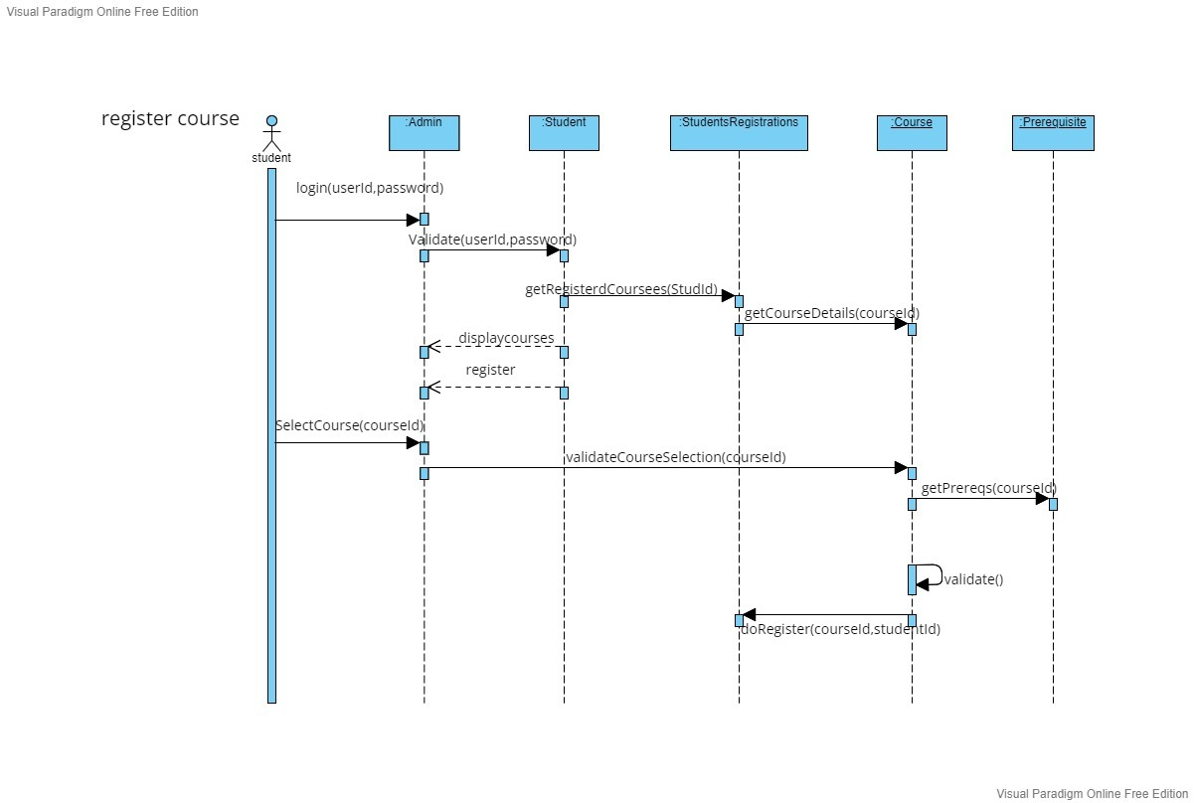

Figure 5. Sequence Diagram for Register Course

### Internal Chat

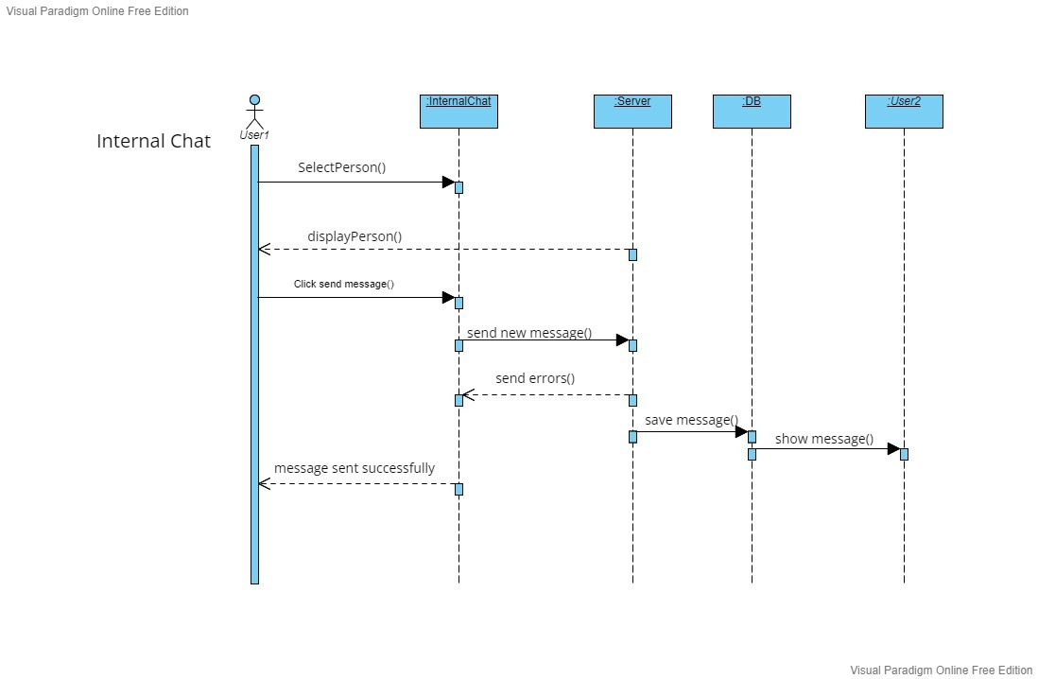

Figure 6. Sequence Diagram for Internal Chat Between Professors or TAs and Students

### View Office Hours

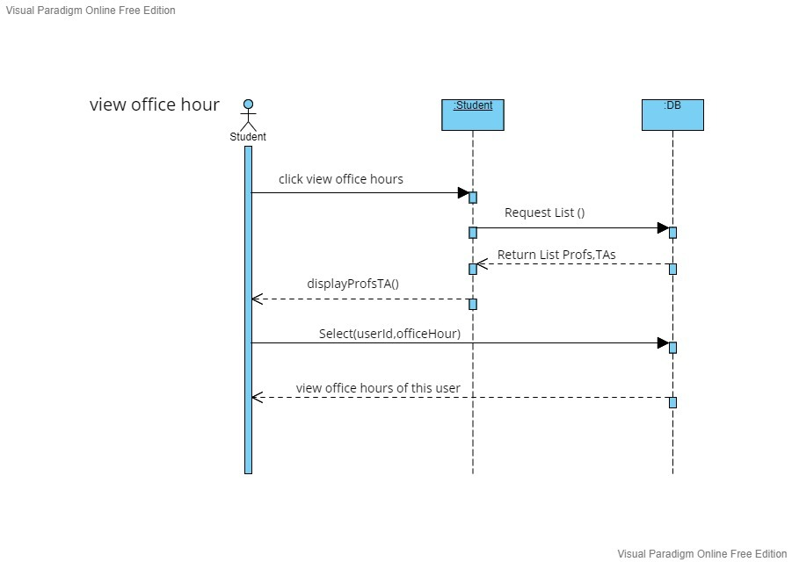

Figure 7. Sequence Diagram for Student to View Office Hours of a Professor or TA

### View Schedule

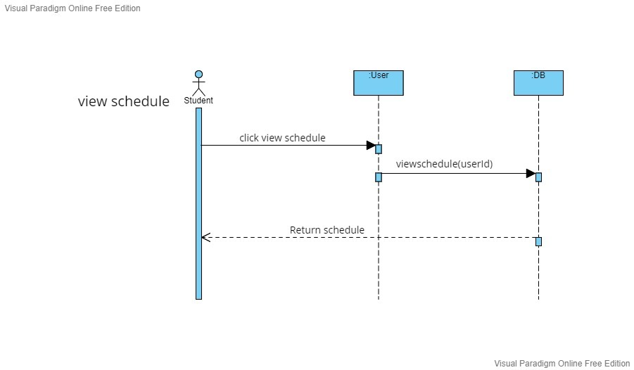

Figure 8. Sequence Diagram for Student to View His/Her Schedule

## Web Persona

### Student

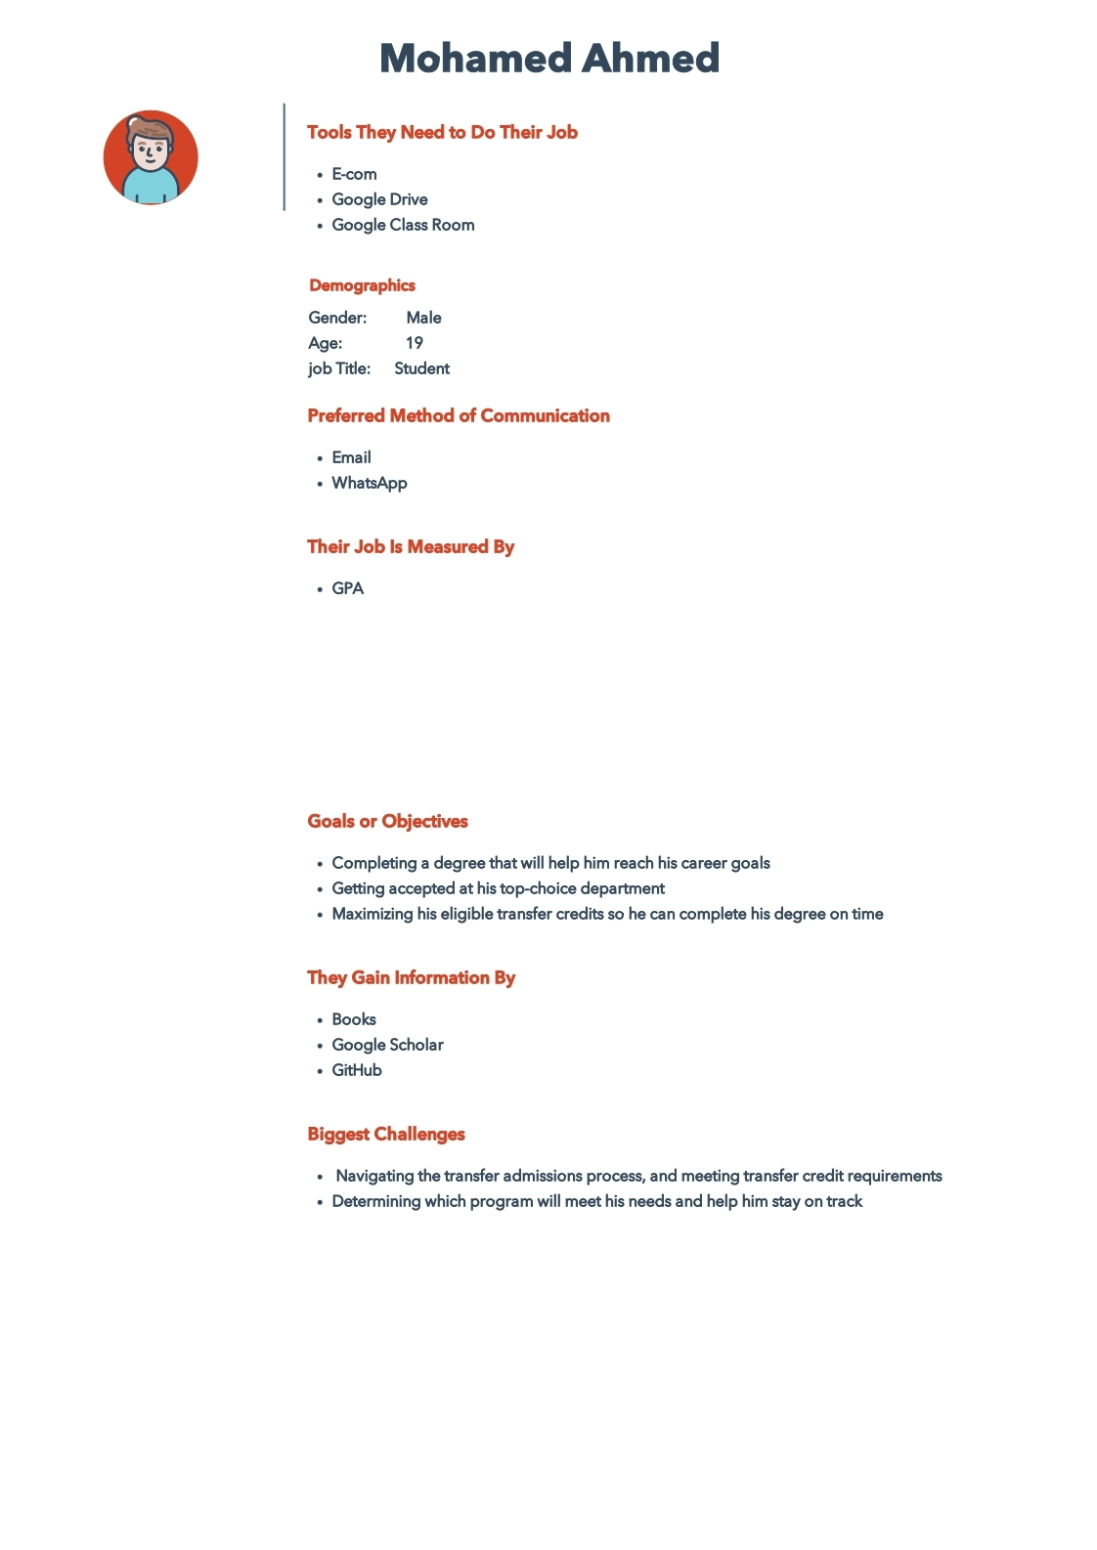

Figure 9. Student Persona

### Professor

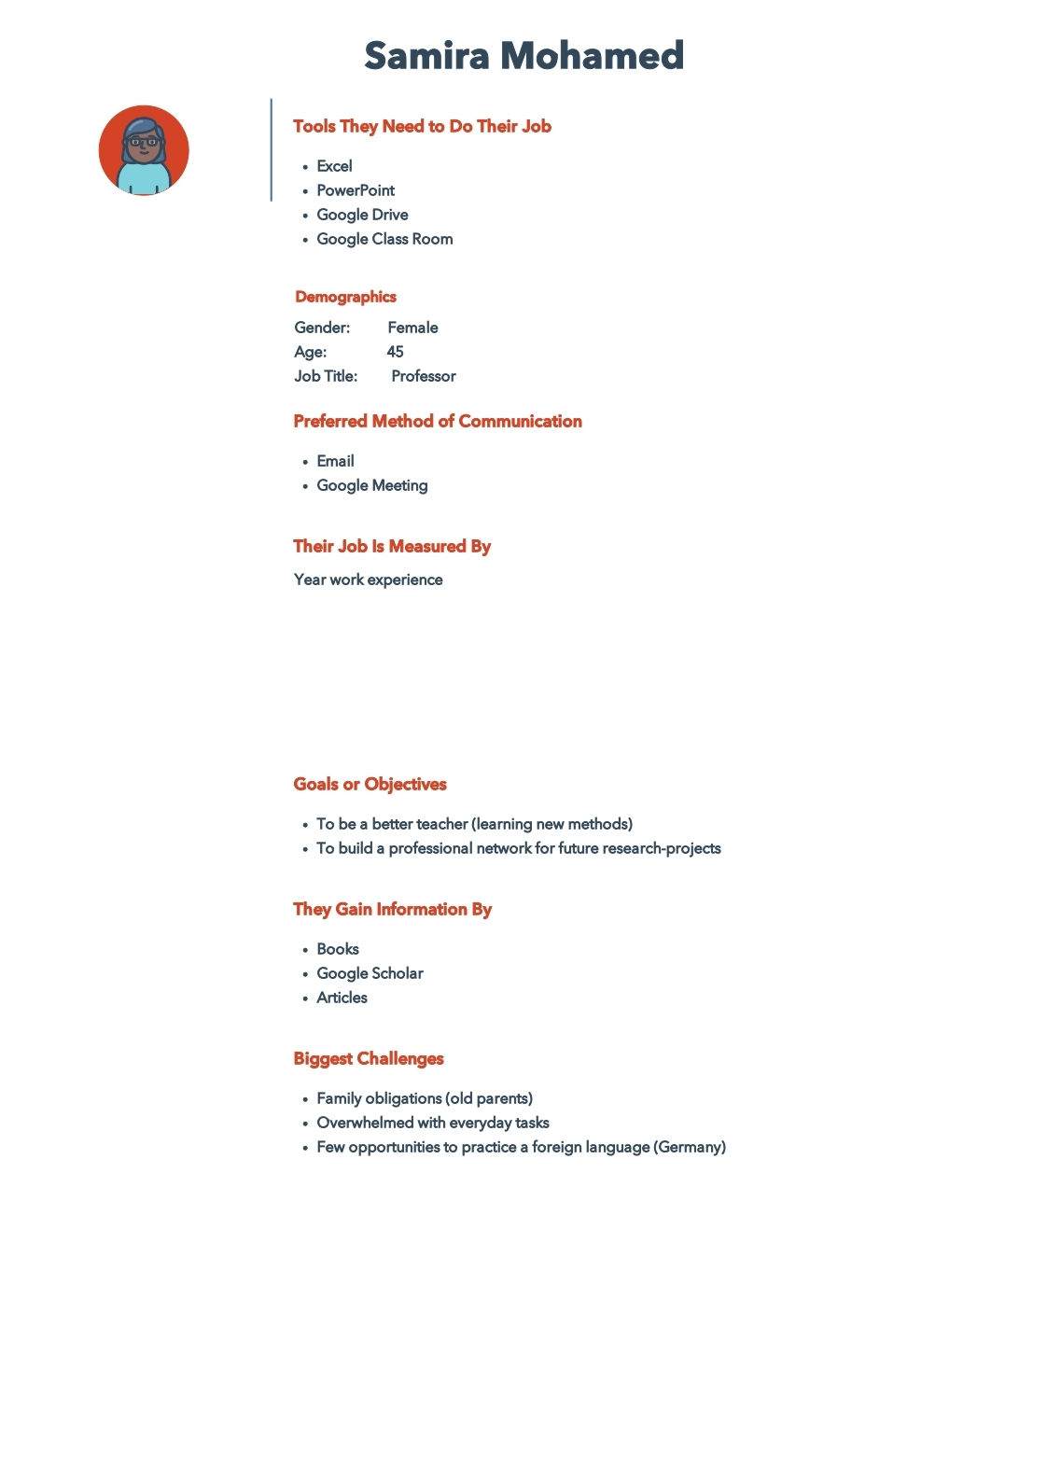

Figure 10. Professor Persona

### Teaching Assistant

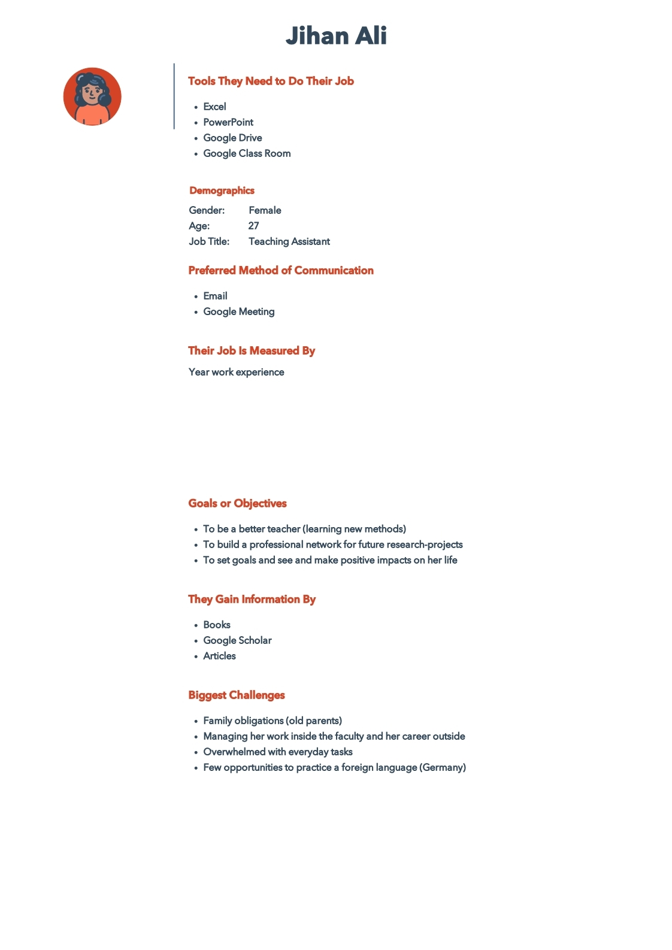

Figure 11. TA Persona

### Student Affairs Employee

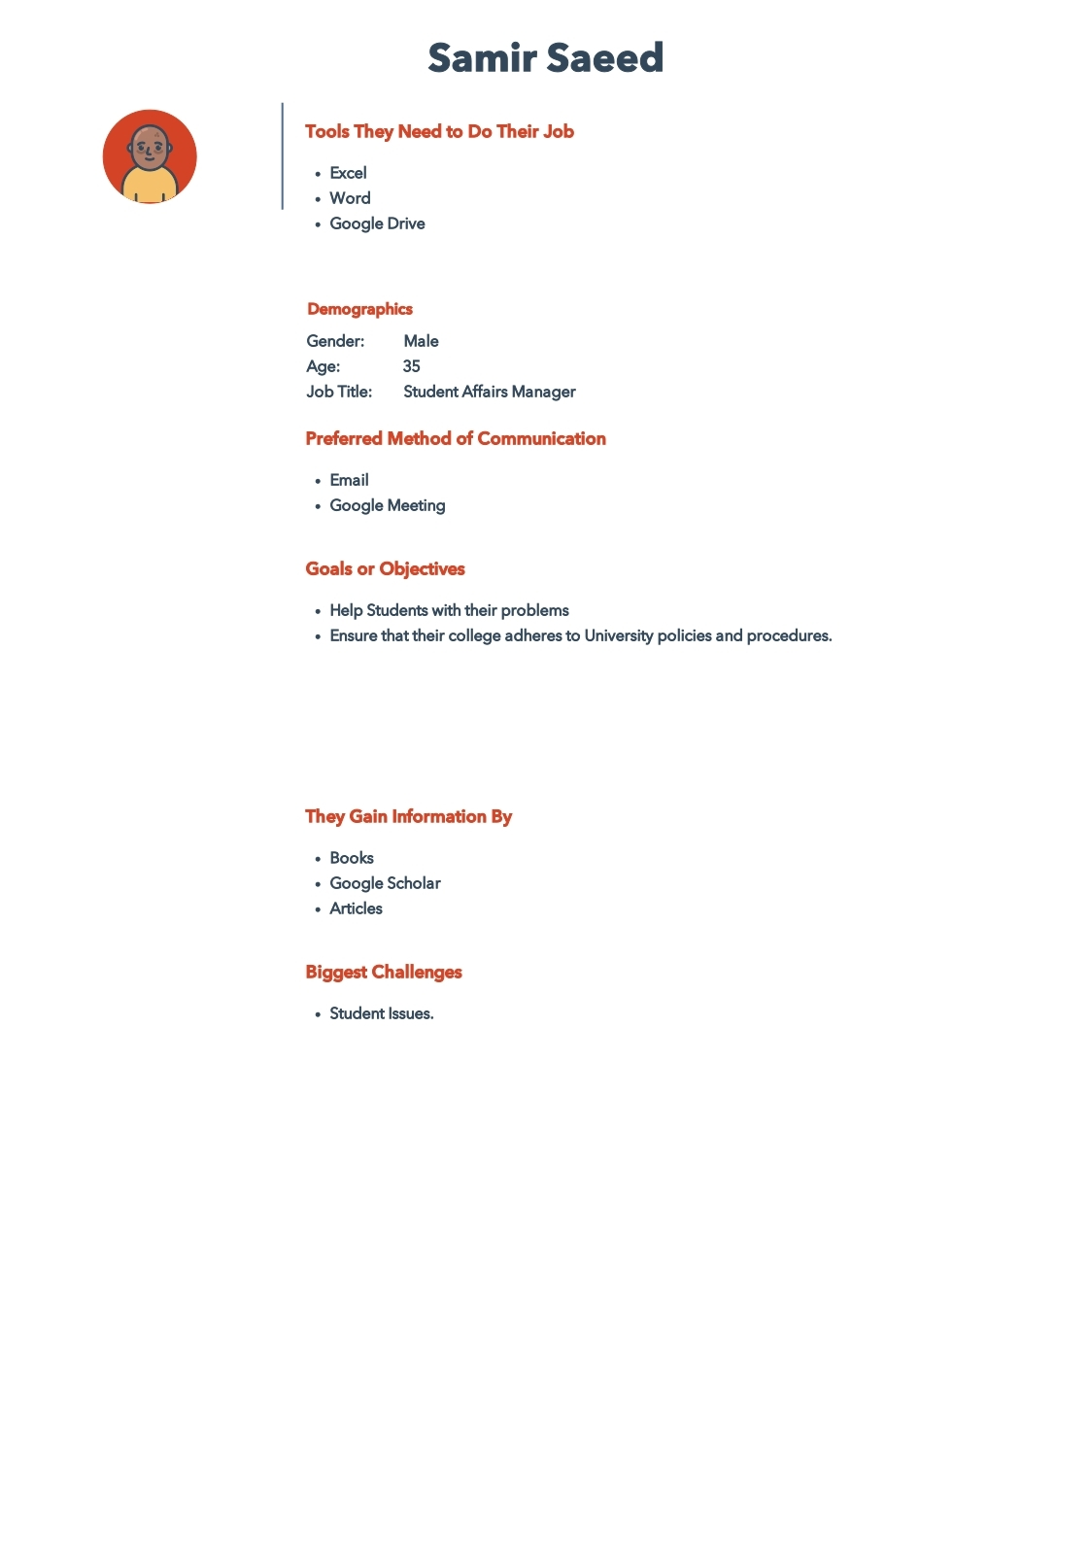

Figure 12. Student Affairs Employee Persona

### Admin

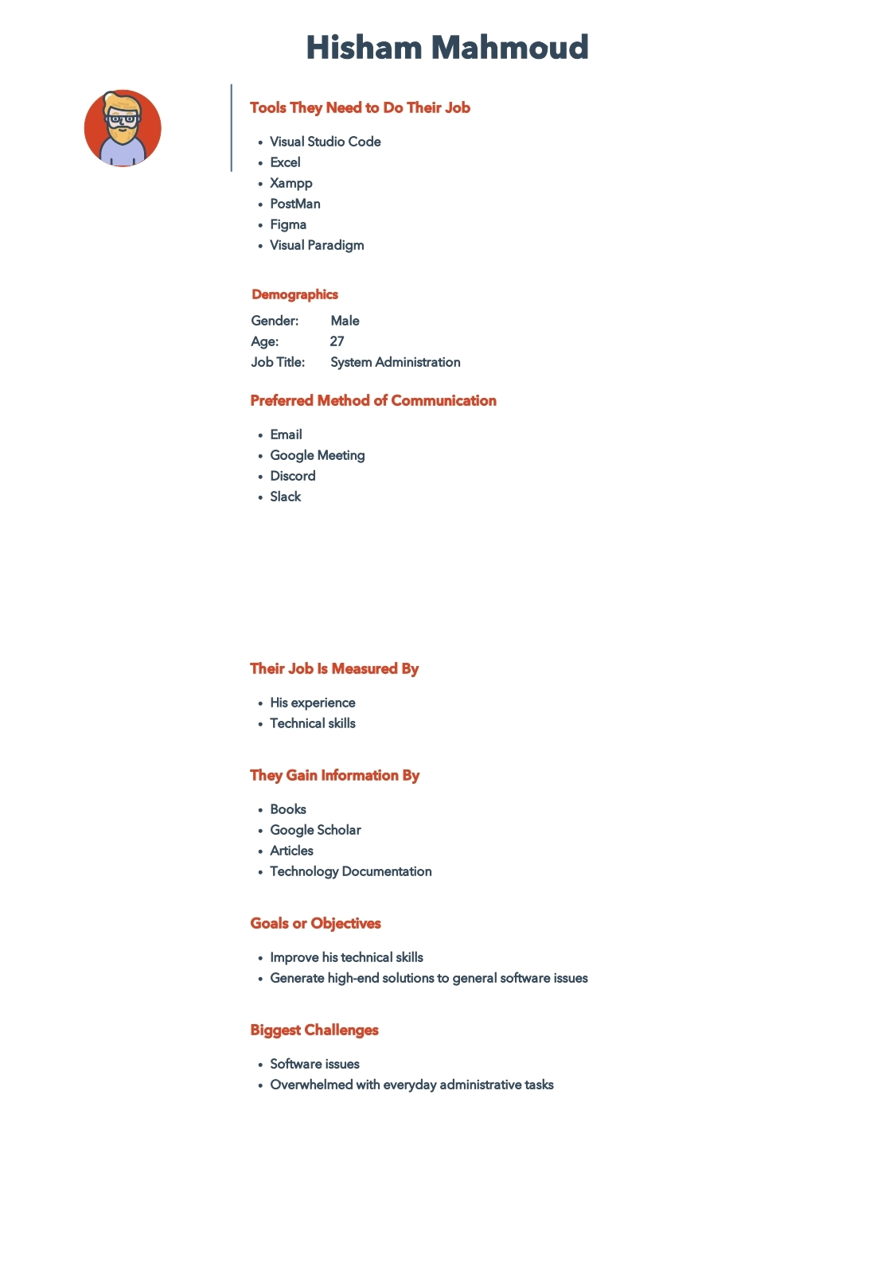

Figure 13. Admin Persona

# Design and Implementation

## System Prototype Screens

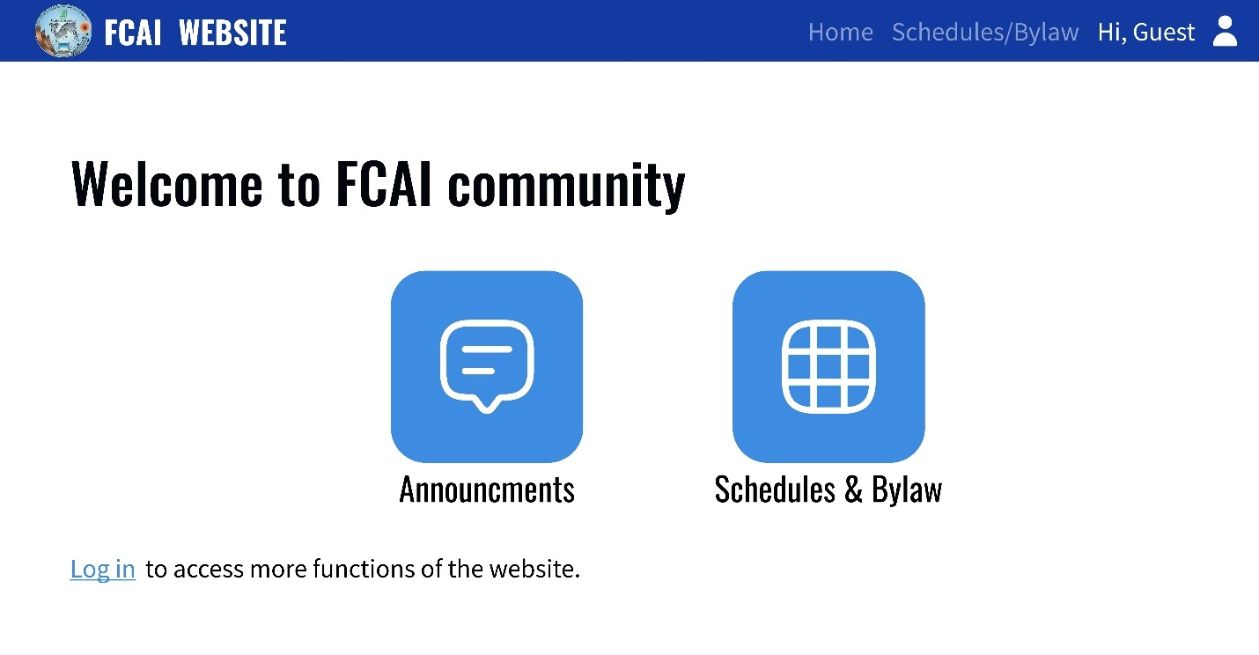

Figure 14. Student Home - Not Logged in Screen

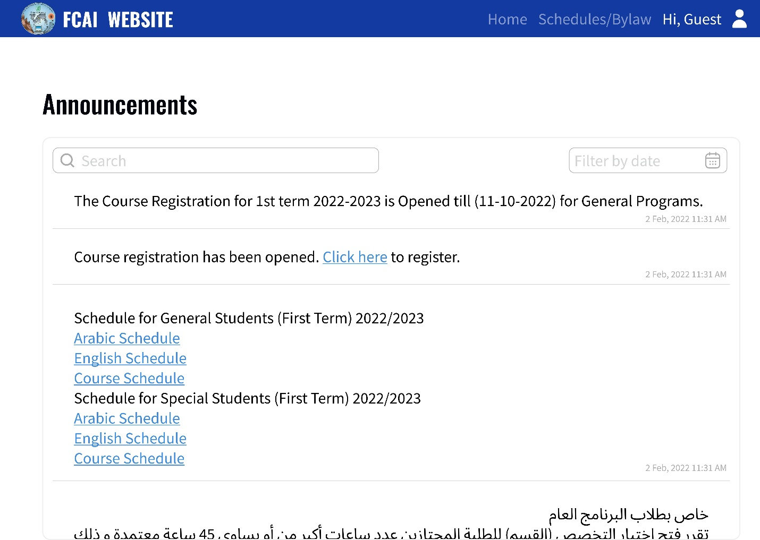

Figure 15. Announcements - Not Logged in Screen

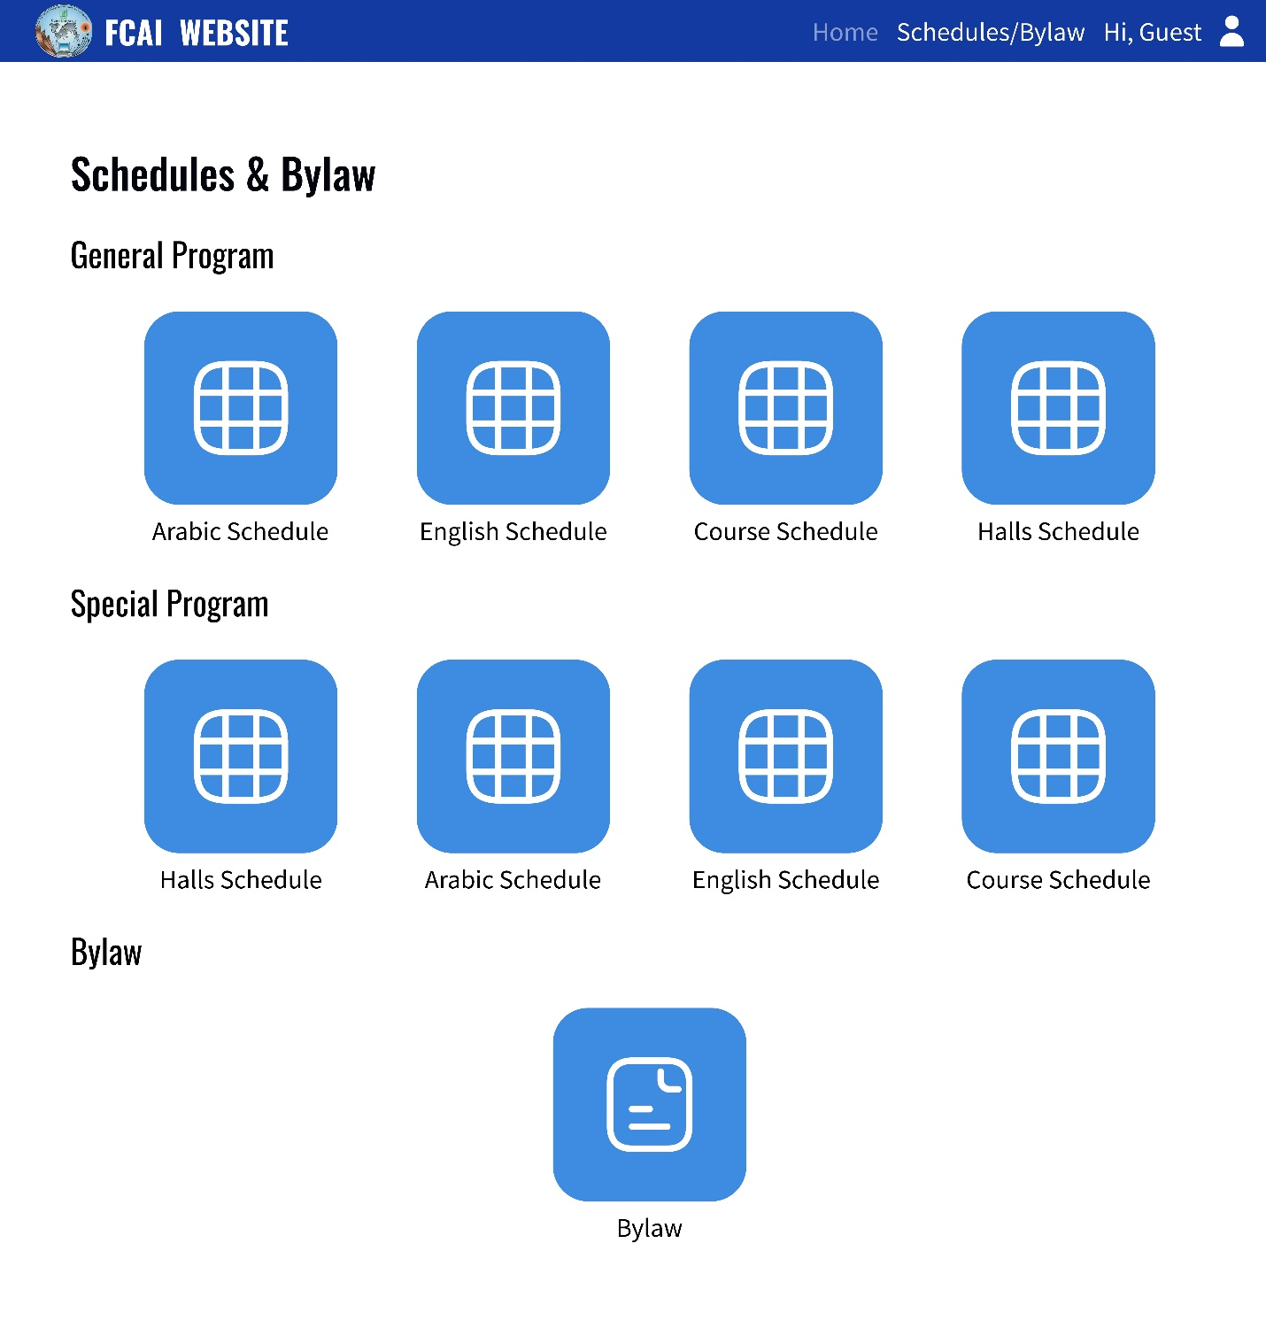

Figure 16. Download Schedule or Bylaw - Not Logged in Screen

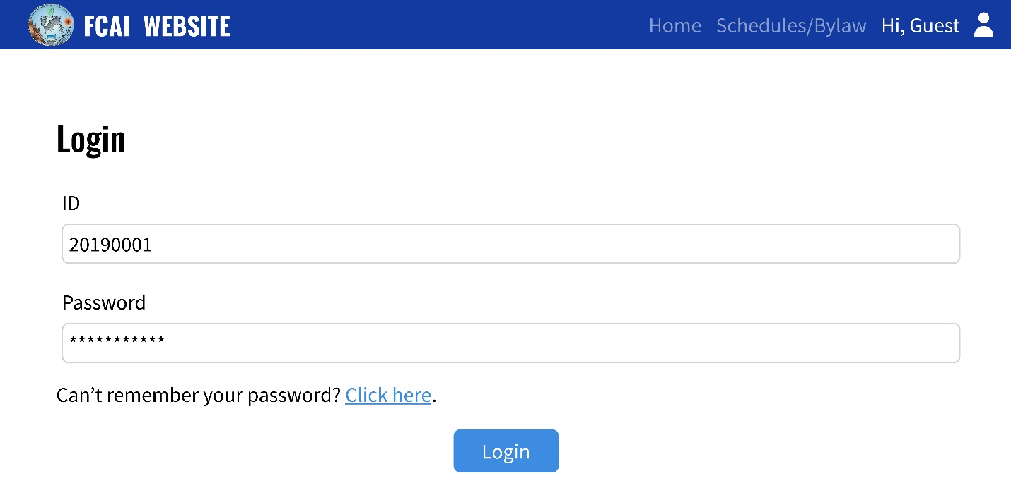

Figure 17. Log in Screen

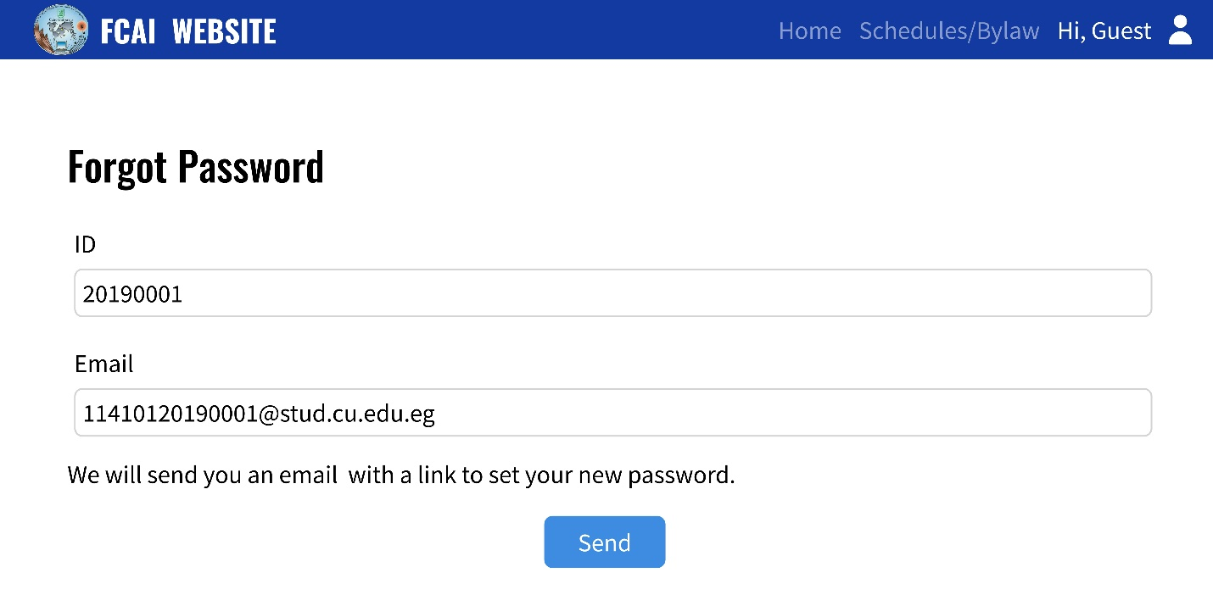

Figure 18. Forgot Password Screen

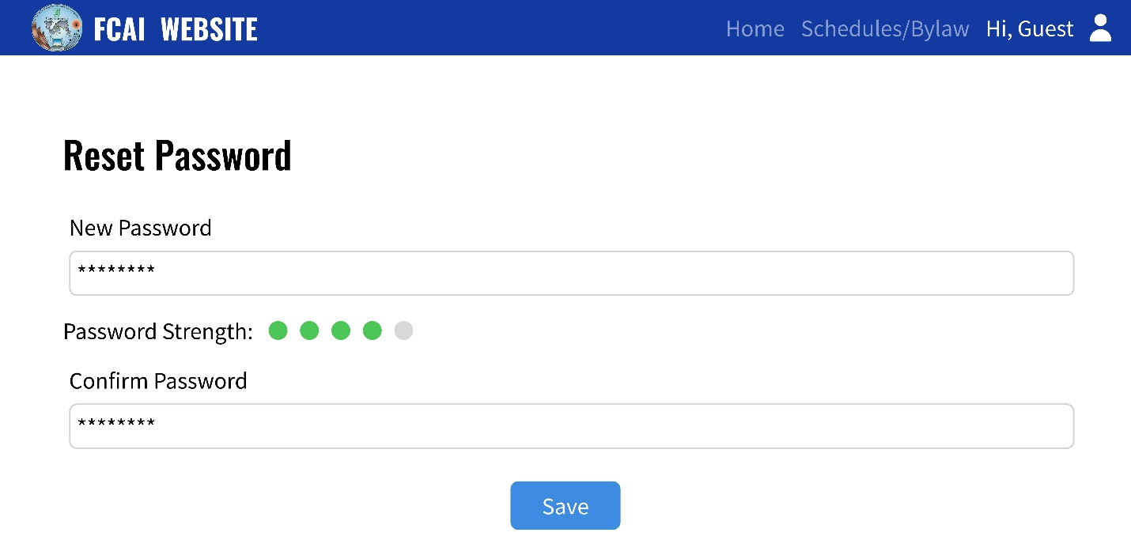

Figure 19. Reset Password Screen

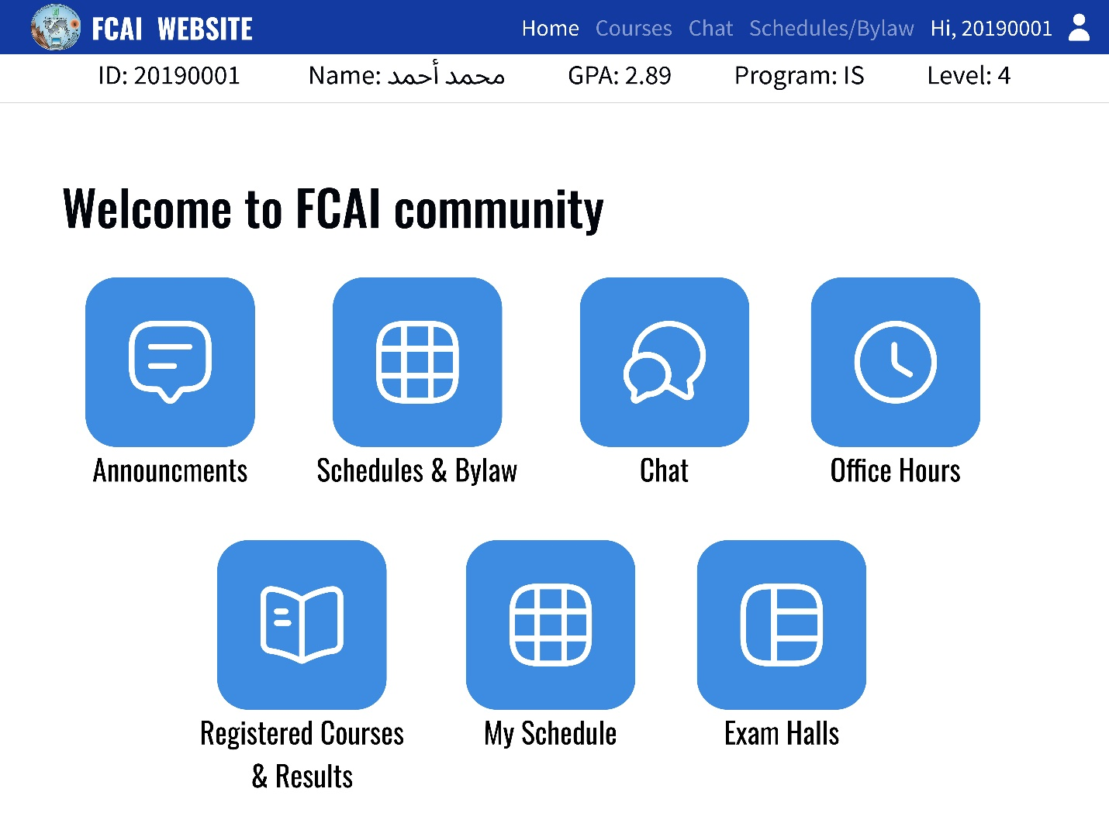

Figure 20. Home Screen

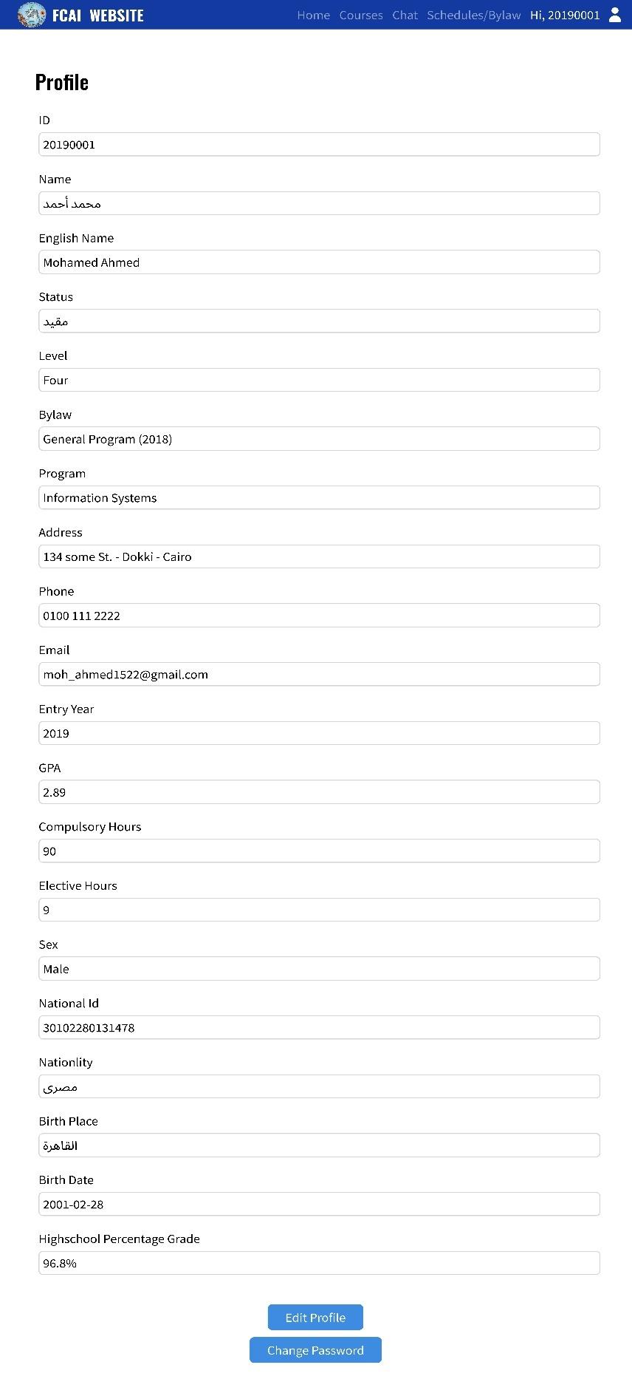

Figure 21. View Profile Screen

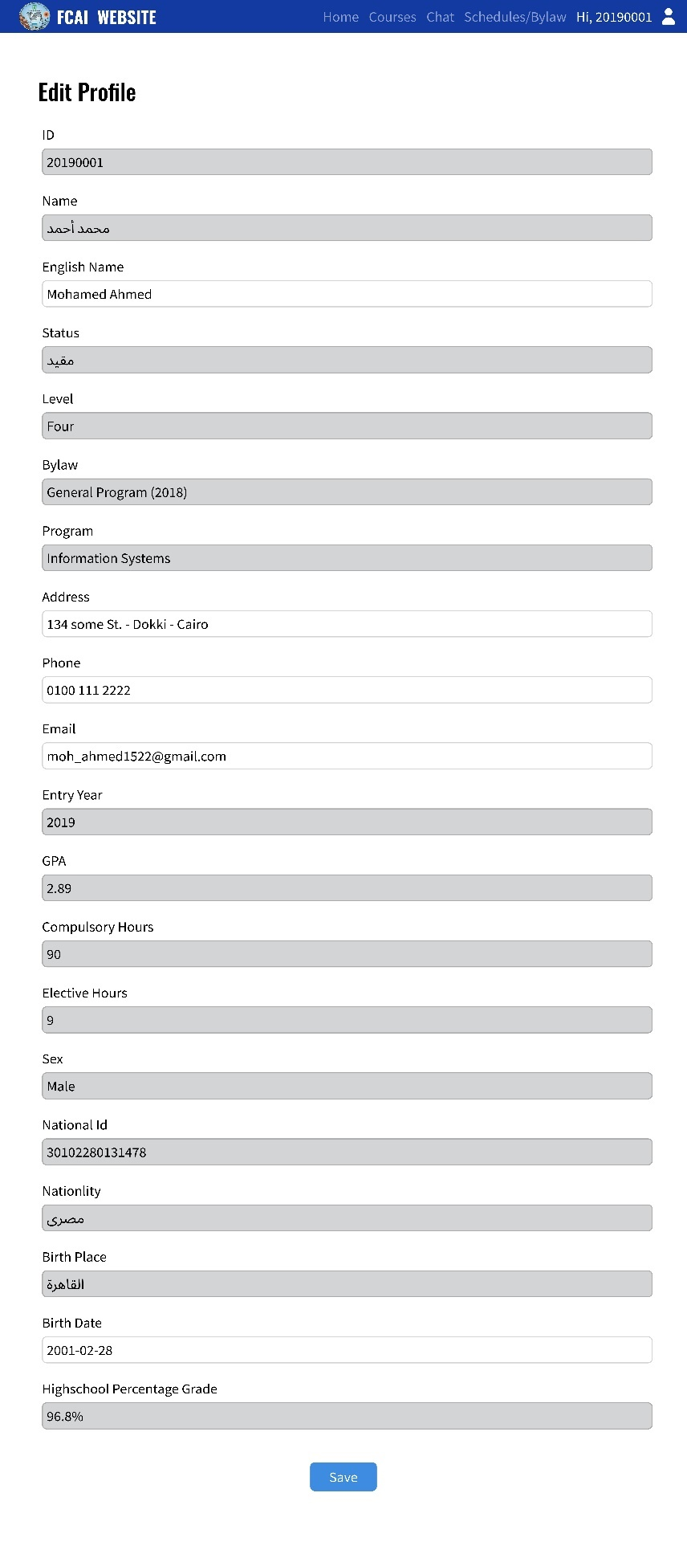

Figure 22. Edit Profile Screen

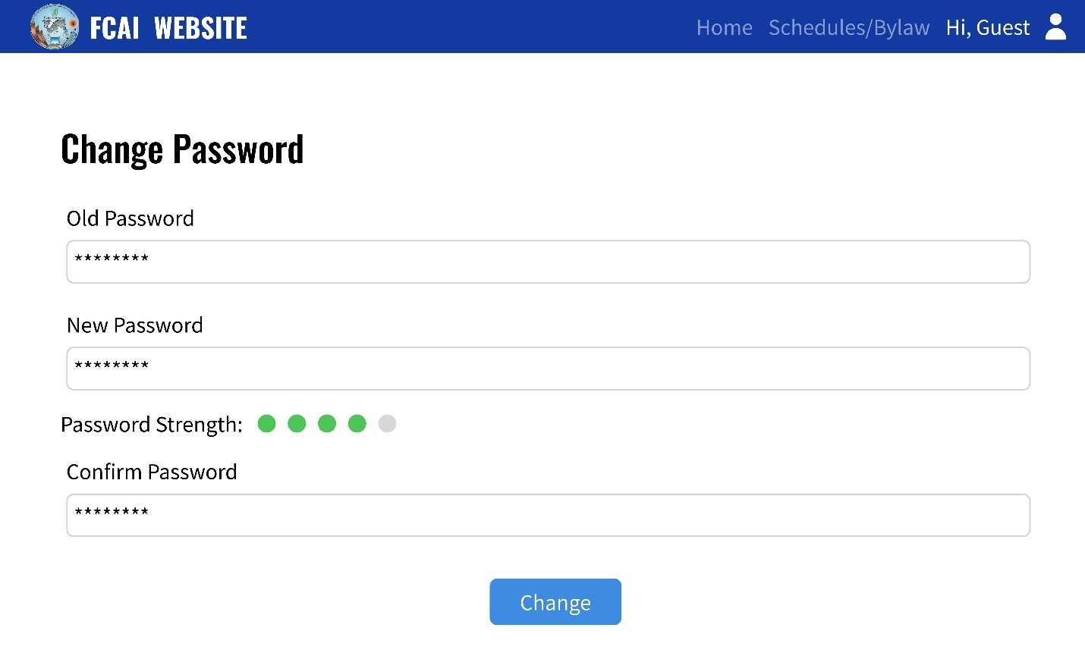

Figure 23. Change Password Screen

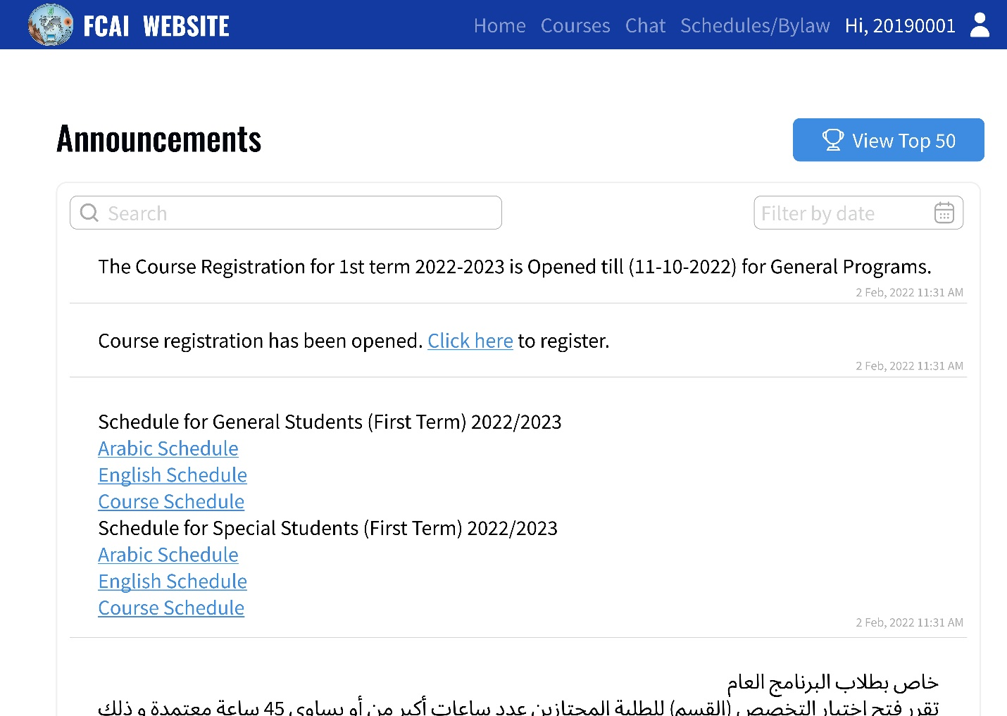

Figure 24. Announcements Screen

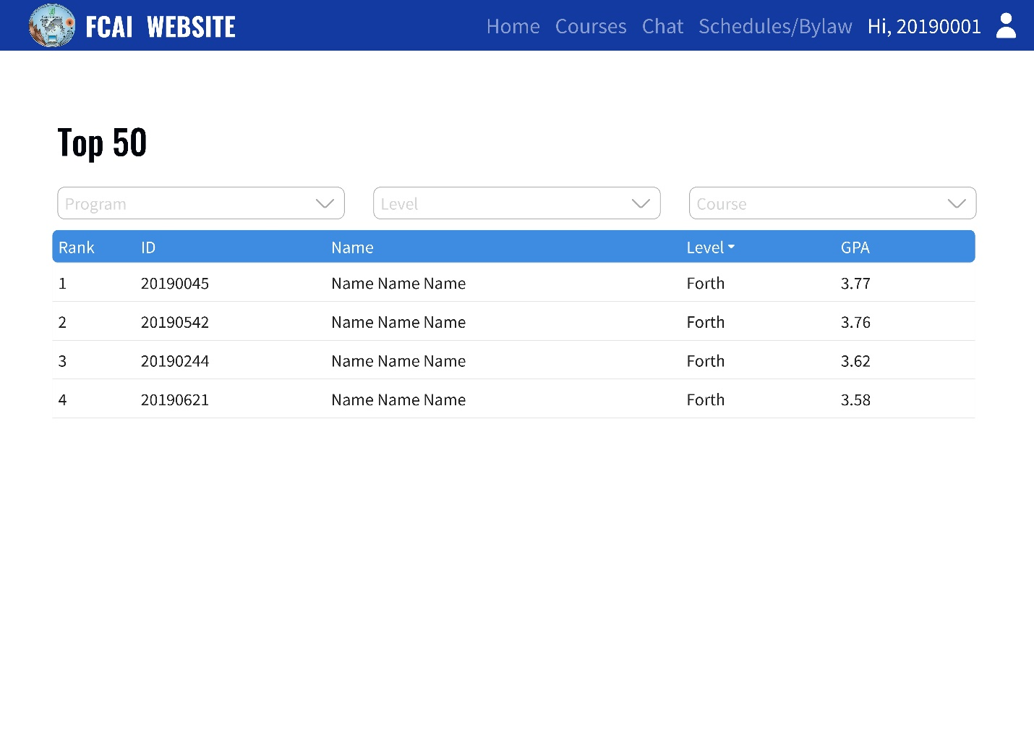

Figure 25. Top 50 Screen

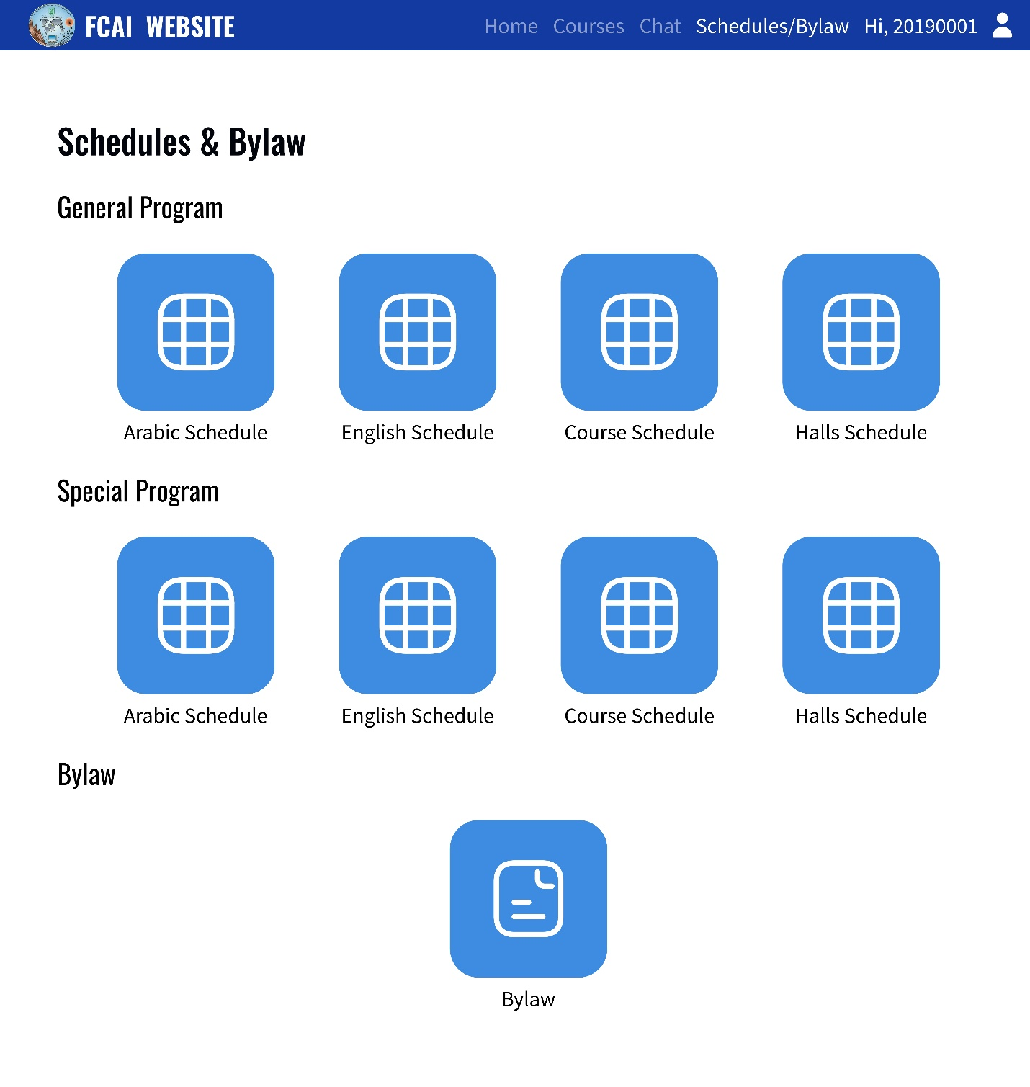

Figure 26. Download Schedules or Bylaw Screen

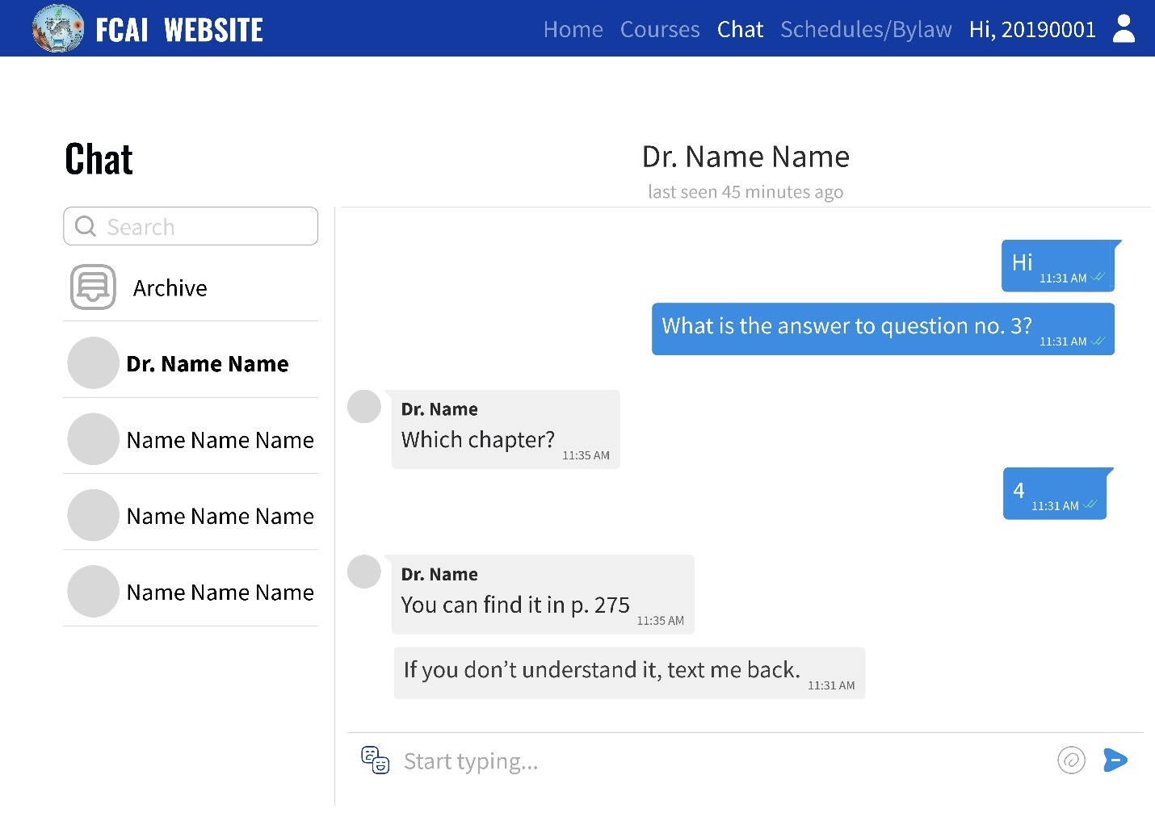

Figure 27. Chat Screen

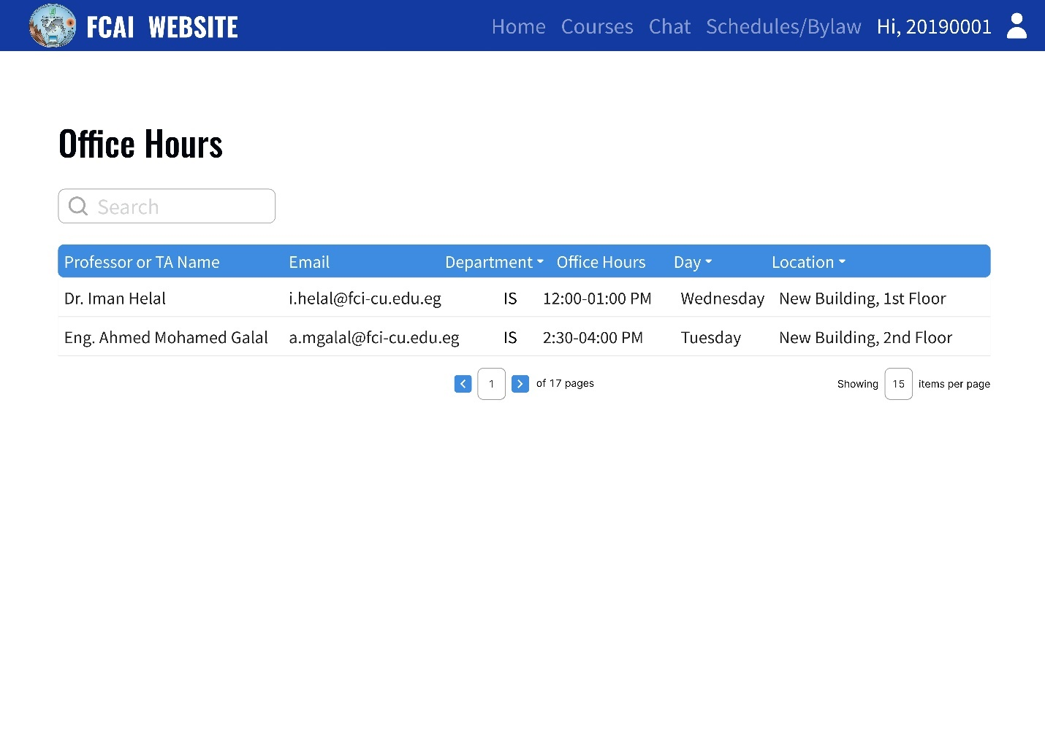

Figure 28. Office Hours Screen

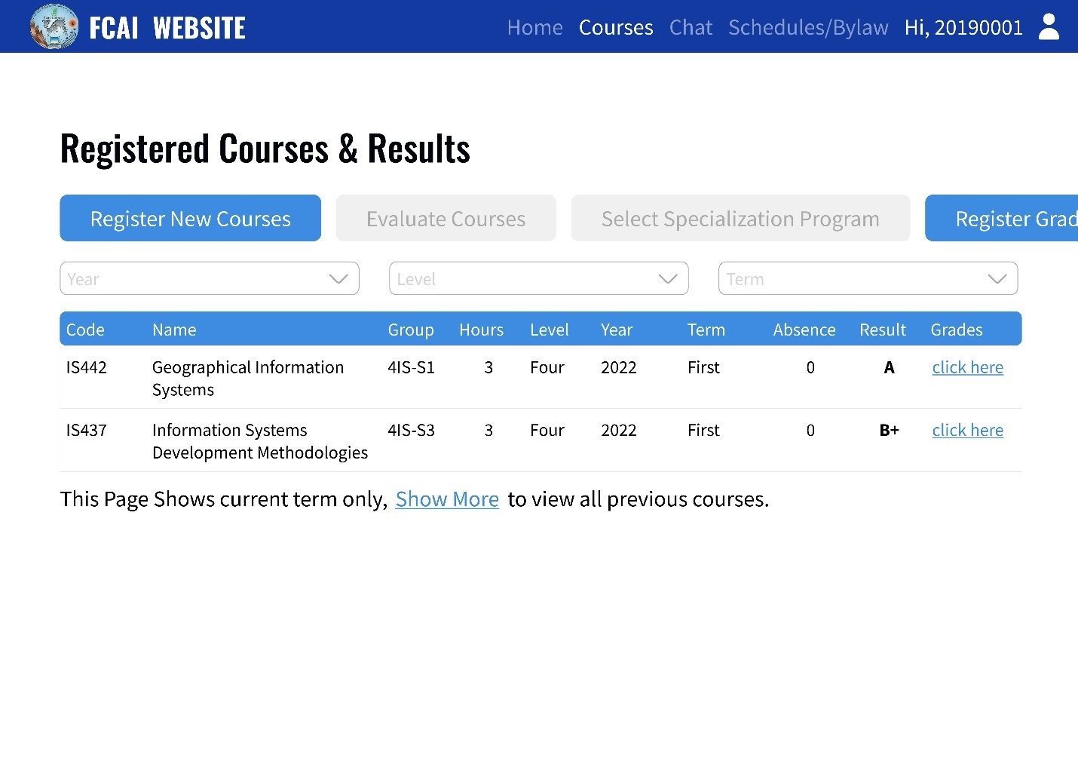

Figure 29. Registered Courses Screen

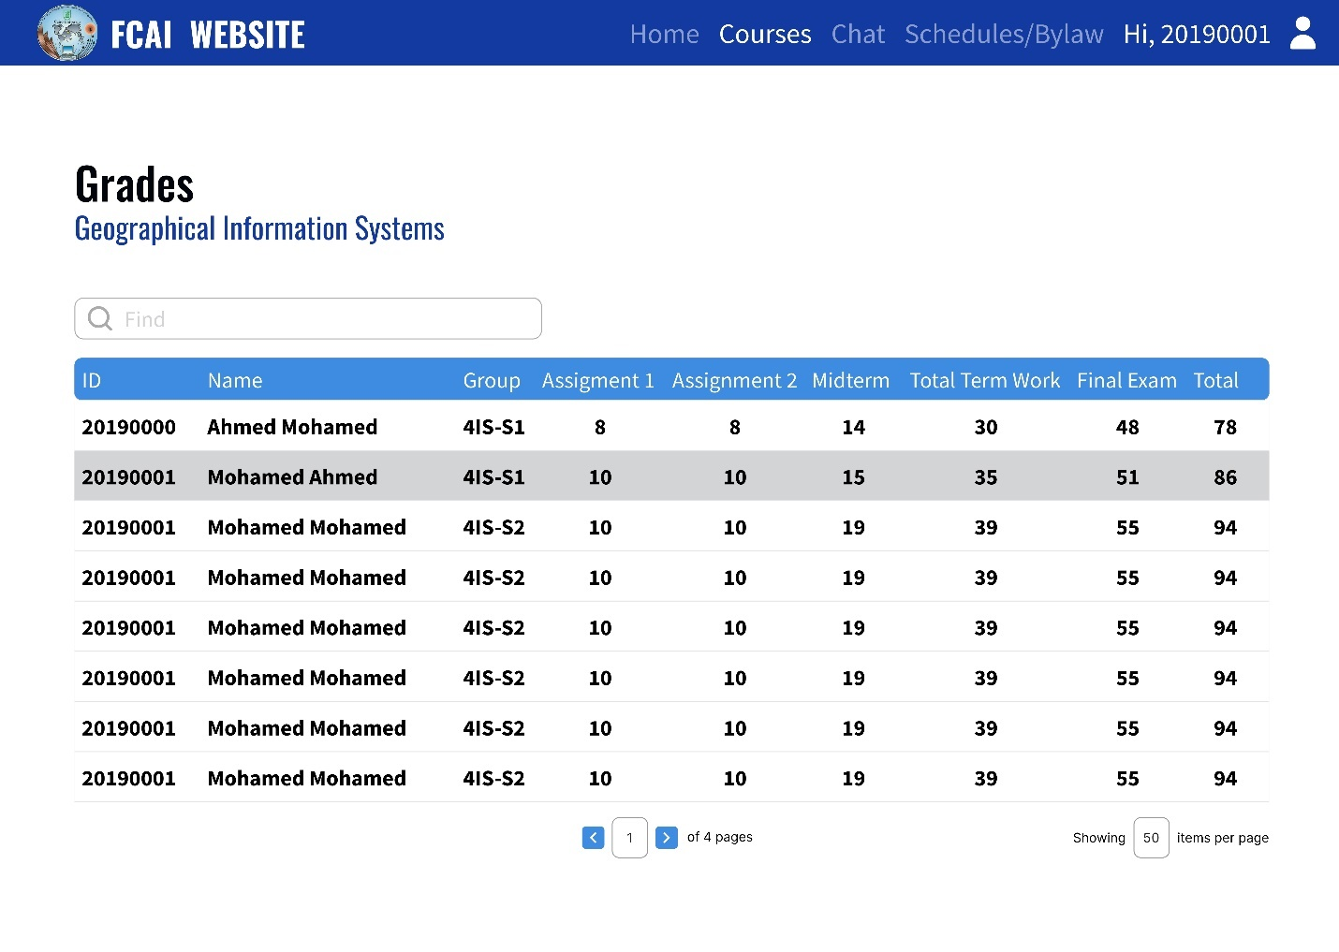

Figure 30. Grades Screen

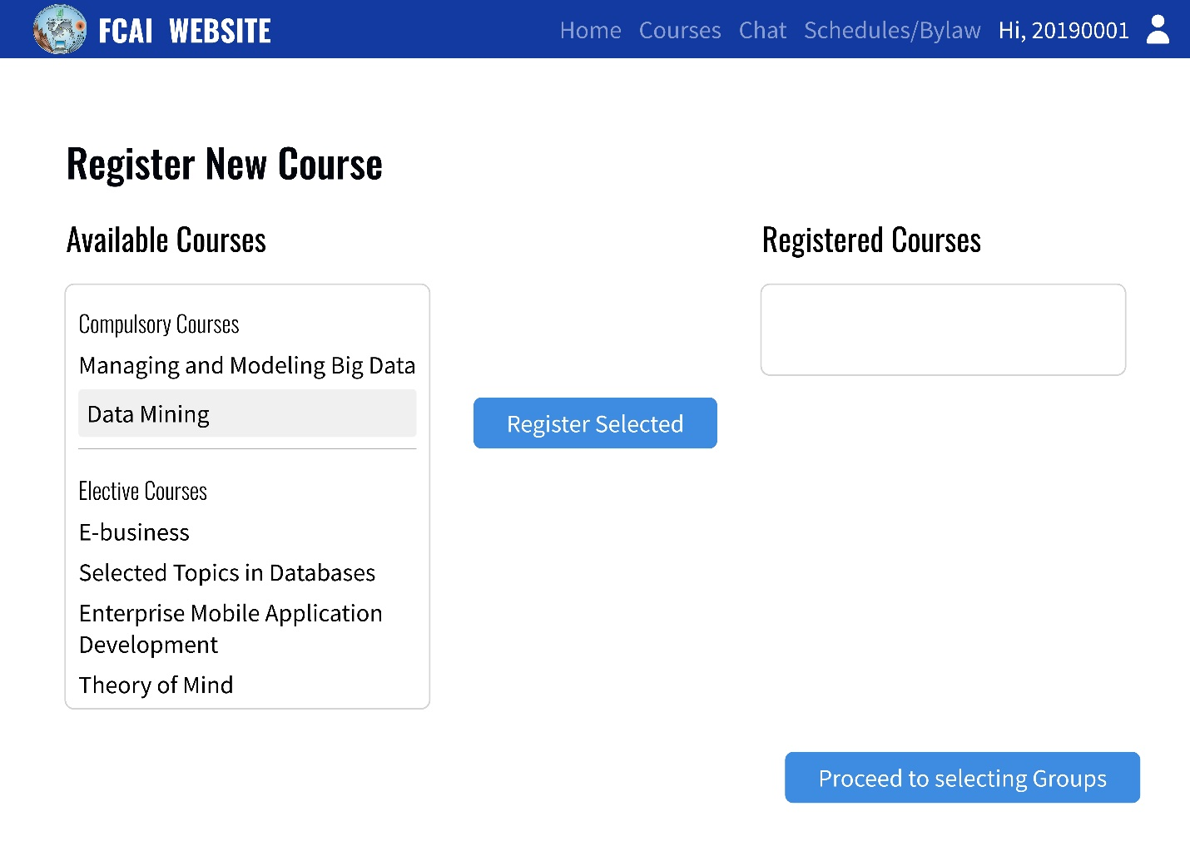

Figure 31. Register New Course Screen

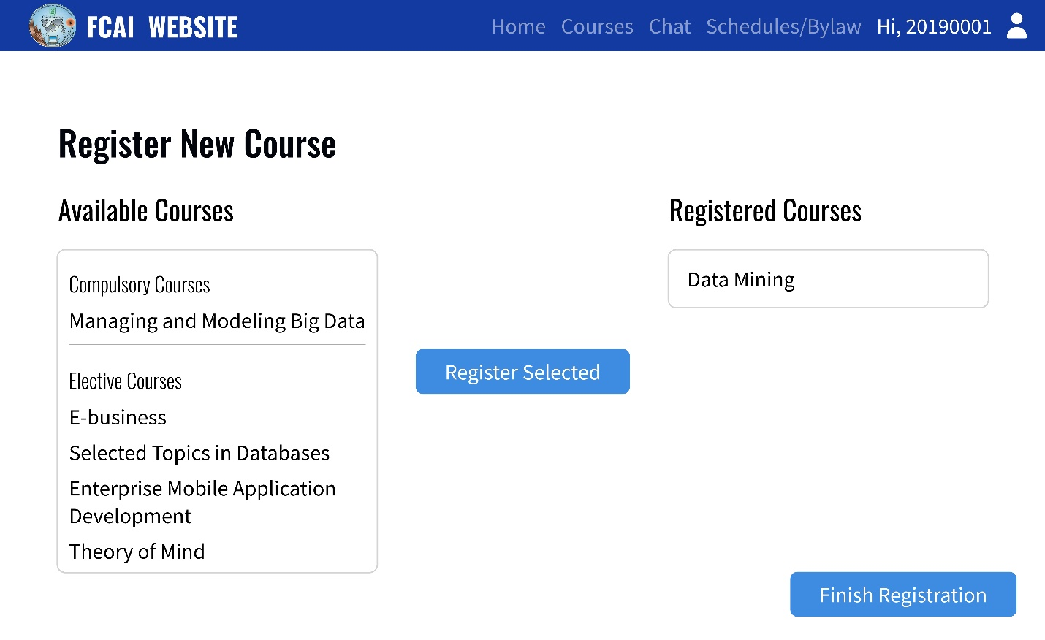

Figure 32. New Course Added Screen

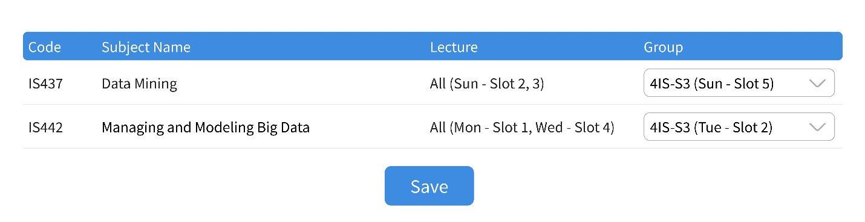

Figure 33. Select Groups Screen

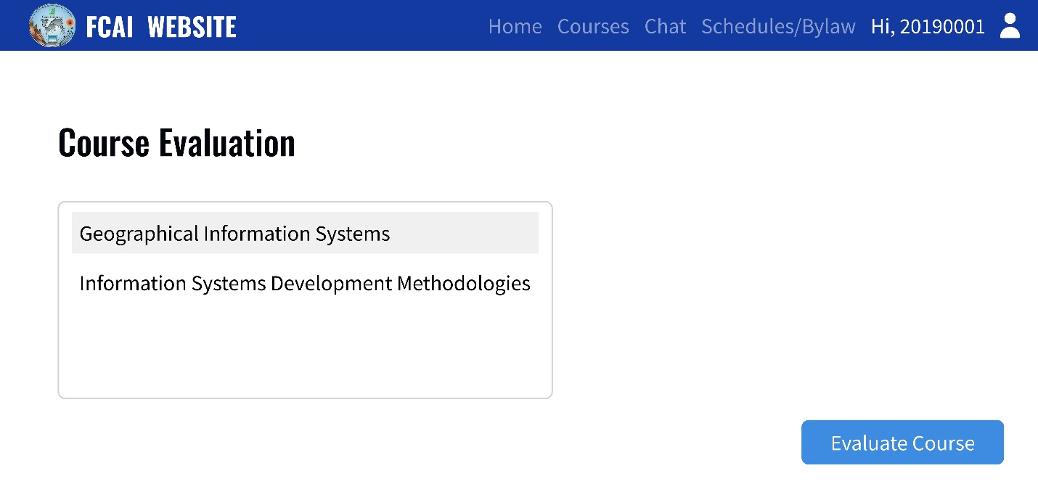

Figure 34. Choose Course to Evaluate Screen

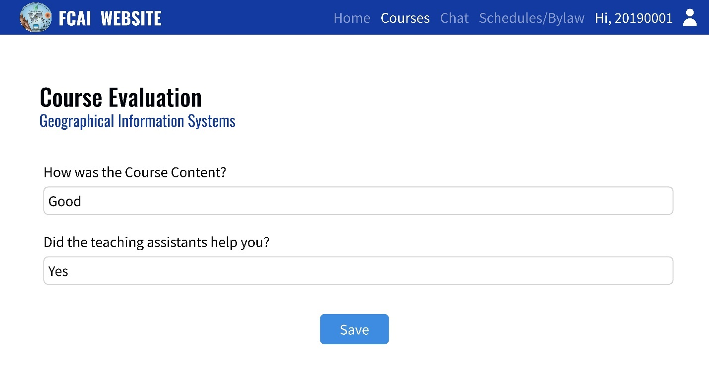

Figure 35. Evaluate Course Screen

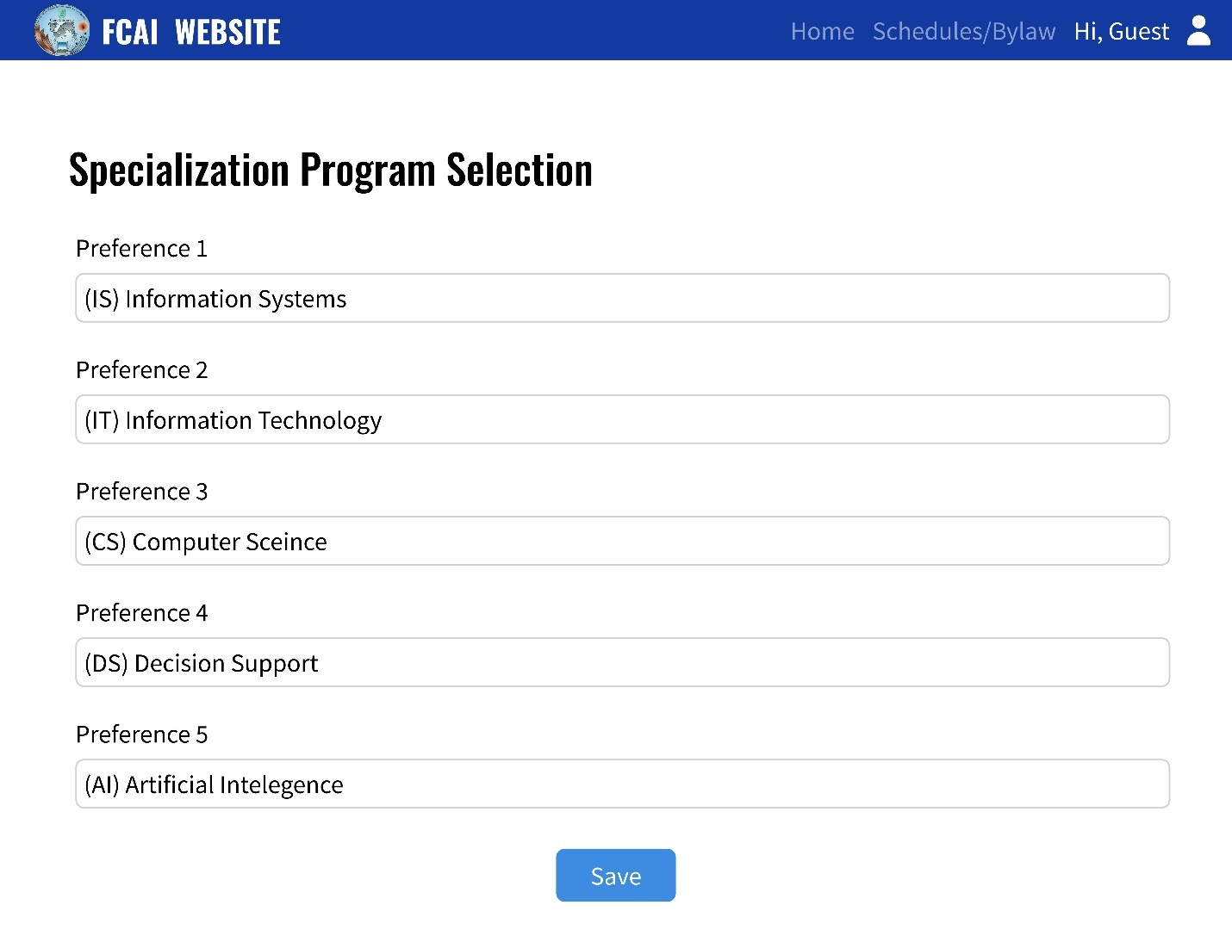

Figure 36. Specialization Program Selection

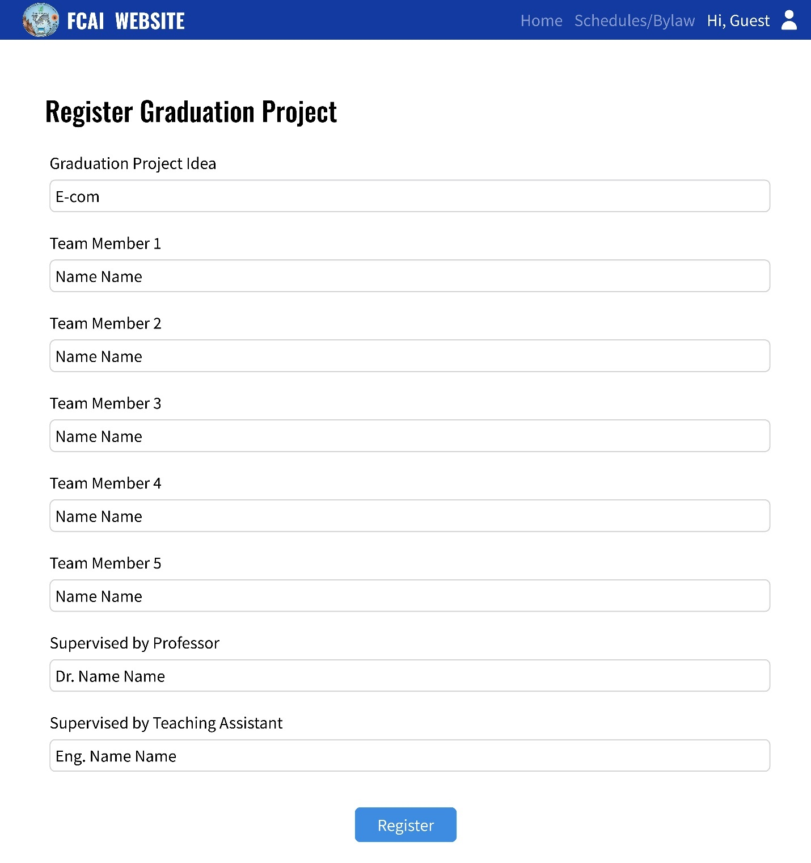

Figure 37. Register Graduation Project Screen

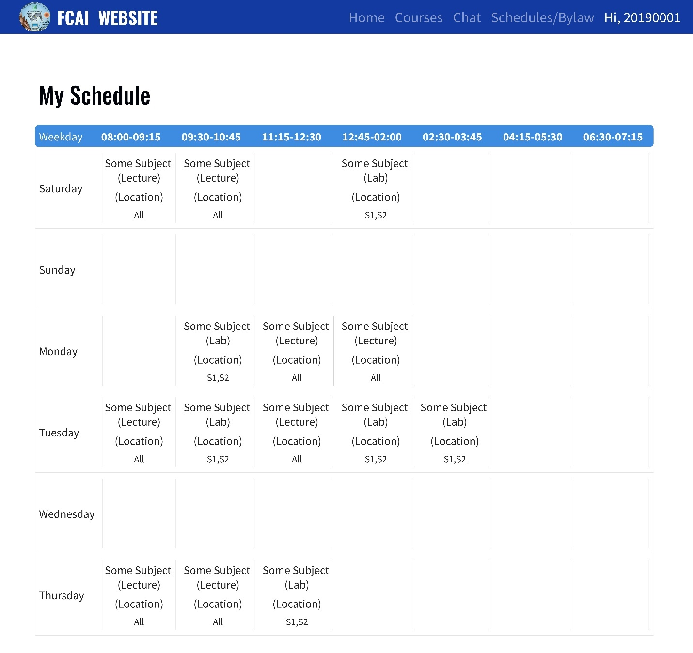

Figure 38. My Schedule Screen

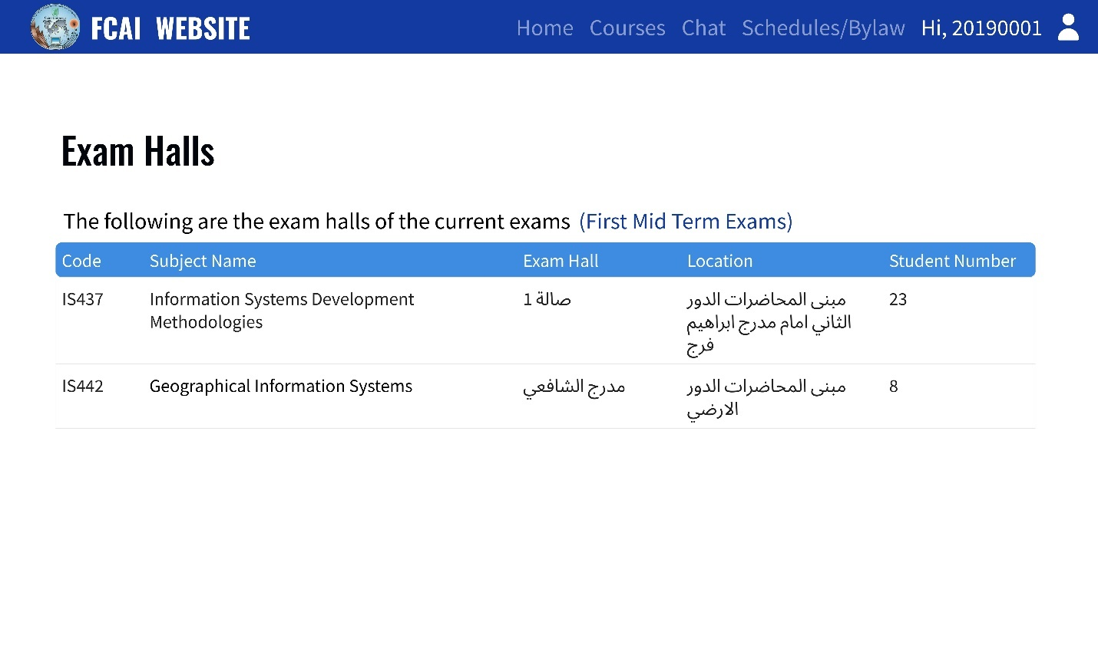

Figure 39. Exam Halls Screen

# Chapter 5 Testing and Evaluation

## 5.1 Testing approach

Our testing approach is manual testing. We have used a variety of testing techniques, including functional testing, and integration testing. Our team divided into three groups. Each group tests the work of the other, and we have used agile testing methodologies to ensure that testing is iterative and ongoing.

## 5.2 Test methodology

Our test methodology consists of several phases, including test planning, test design, test execution, and test reporting. We have used a risk-based approach to prioritize testing activities and ensure that we focus our testing efforts on the areas of the system that are most critical.

## 5.3 Test coverage

## We ensure that our testing covers all the key features and functionality of the system, including:

## Authentication: ensure that the users’ login before accessing any page and enable them to reset the password.

* Authorization: used to determine what actions that user is allowed to perform.

## Registration and course enrollment: ensure that students can successfully register for courses, and that the course enrollment process is error-free and accurately reflects the course list and scheduling information.

## Notifications: push notifications for each new announcement that are delivered in a timely manner and contain the correct information.

* Internal chat: ensure that messages are delivered successfully and enable the professor or TA to block student if annoy them.
* Course evaluation: ensure that the evaluation process is error-free and that the evaluation results are accurately reflected in the system.
* Student records: ensure that all student records are accurately maintained and updated, including grades and exam results.
* Statistics and reporting: ensure that all reports and statistics are accurate and up to date.
* Course feedback: ensure that feedback is collected accurately and that the feedback results are accurately reflected in the system.
* Search functionality: ensure that the search functionality is accurate and returns the correct results.
* User profiles: ensure that user profiles are accurate and up-to-date, and that all user information is properly maintained.

## 5.4 Test schedule

We have conducted testing activities throughout the development process, with an emphasis on early and frequent testing to identify issues as soon as possible. We have also conducted a final round of testing prior to release, to ensure that the system is stable.

## 5.5 Test cases

|  |  |  |  |  |  |  |  |  |
| --- | --- | --- | --- | --- | --- | --- | --- | --- |
| Test ID | Test case | Test scenario | prerequisites | Test procedure | Test data | Expected result | Actual result | Status |
| 1 | Valid login  (Student) | Enter valid username and password | Should be registered | 1-Enter valid username.  2- Enter valid password | username:  20190022 password:  ali1234 | Logged in | Login successfully | pass |
| 1 | Valid login  (Professor or TA) | Enter valid username and password | Should be registered | 1-Enter valid username.  2- Enter valid password | username:  ihelal  password:  iman1234 | Logged in | Login successfully | pass |
| 1 | Valid login  (Admin) | Enter valid username and password | Should be registered | 1-Enter valid username.  2- Enter valid password | username:  admin  password:  admin1234 | Logged in | Login successfully | pass |
| 1 | Invalid login | Enter invalid username or password |  | Enter invalid username or password | username:  201900022  password:  al1234 | Cannot login | Login failed and error message appear: username or password does not correct. | pass |
| 2 | Valid Forget password | Enter valid email | Should be registered | Enter valid email | ali20190022@gmail.com | Receive massage on that email to go to reset password page | Reset password successfully | pass |
| 2 | Invalid Forget password | Enter invalid email |  | Enter invalid email | ali@gmail.com | Cannot receive massage on that email | Reset password failed. | pass |
| 3 | Valid GP form registration | Fill the GP form | Should be in third level and the admin opened the form for registration | 1- Enter team members IDs  2- Enter requested professor and TA  3-project idea  4-project requirements | team members IDs :20190234,20190233,20190156,20190084,20190267  requested professor: Iman Helal  requested TA: Ahmed Galal  project idea: updated E-com | Form submitted and sent to the requested professor and TA to accept or reject it | Form un submitted successfully | pass |
| 3 | Invalid GP form registration | Fill the GP form with invalid IDs | Should be in third level and the admin opened the form for registration | 1- Enter invalid team members IDs  2- Enter requested professor and TA  3-project idea  4-project requirements | team members IDs :201900234,201902033,201901156,201900084,201900267  requested professor: Iman Helal  requested TA: Ahmed Galal  project idea: updated E-com | Form cannot be submitted | Form un submitted | pass |
| 4 | Valid course Registration | Select the course and the section number | Should be login and the admin has opened the course registration | 1-Select the course  2-Select the section number | Course: Software1  Section: S2 | Registration Done and navigated to My registered courses table | Register successfully | pass |
| 4 | Invalid course Registration | Select the course and the section number that conflict with another section | Should be login and the admin has opened the course registration | Course:  1-Select the course  2-Select the section number  Another course:  1-Select the course  2-Select the section number | Course: Software1  Section: S2 (1st slot Monday)  Another course:  OS  Section: S3 (1st slot Monday) | Registration of second section doesn’t be completed | Registration failed and error message : there is a conflict please select another section | pass |
| 4 | Invalid course Registration | Select the course and the section number that there credit hours less than the limit of the number of credit hours per semester | Should be login and the admin has opened the course registration | 1-Select the course  2-Select the section number | Course: Software1  Section: S2 | Registration doesn’t be completed | Registration failed and error message : The registered courses credit hours less than limit of credit hours per semester | pass |
| 5 | Receive notifications | A user is received a notification via email | Admin add an announcement | 1- open the email  2- go to the announcement page |  | A user receives a notification via email | Notification received as expected | pass |
| 6 | View registered courses | Student clicks on registered courses and results icon | A student is logged in | Student clicks on registered courses and results icon |  | Student can view their registered courses | Registered courses are displayed correctly | pass |
| 7 | Internal chat | Student wants to communicate with professor or TA and vice versa | Users are logged in | 1- click on chat icon  2- Student select a professor or TA and vice versa to chat with  3-send a message | Chat message | Message is sent and received successfully | Message is sent and received as expected | pass |
| 8 | Course evaluation | A student wants to evaluate a course they have taken. | Received a notification that the evaluation form has been opened | 1- Click on the course evaluation button.  2- Select the course to be evaluated.  3- Fill in the evaluation form.  4- Submit the evaluation form. | Evaluation form | The course evaluation form is successfully submitted. | Alert saying that the evaluative form has been submitted successfully | pass |
| 9 | View office hours and location | A student wants to view the office hours and location of a professor or a TA. | The student has logged in | 1- Navigate to the office hours and location section.  2- Search for specific professor or Ta | Professor/TA name (to search with) | The office hours and location of the selected professor or TA are successfully displayed. | The office hours and location of the selected professor or TA are successfully displayed. | pass |
| 10 | Push notification whenever the professor or TA is assigned to a course. | A professor or a TA is assigned to a course | Received a notification | 1- Wait for a professor or a TA to be assigned to a course.  2- Check if the professor or TA receives a notification |  | The professor or TA receives notification for the course assignment. | The professor or TA receives notification for the course assignment. | pass |
| 11 | View schedule for specific hall | A professor or a TA wants to view their customized schedule based on selected hall. | The professor or Ta has logged in | Navigate to my place schedule section | The professor or Ta select a specific hall | The professor or Ta’s schedule with the selected hall has been displayed successfully | The schedule has been displayed | pass |
| 12 | Report statistics about student results in specific course | A professor or a TA wants to report statistics about student results in specific course. | The professor or Ta has logged in | 1. Navigate to my courses  2. select a specific course to see the statistics about it | The professor or Ta select a specific course | The statistics report about student results in the selected course is successfully generated and displayed. | The report has been displayed | pass |
| 13 | View all students | A professor or a TA wants to view all the students in courses that he/she teaches | The professor or Ta has logged in | Navigate to view students’ section and filter with (course name, level or course grade) | Search data | The professor or TA can view all the students with their details (student name, course name, course grade, level, semester, GPA) in their courses | Displayed the student details that have been registered the professor or Ta courses | pass |

# Chapter 6 Conclusions and Future Work

Our objective is to develop a website that addresses the challenges encountered by students and facilitates the utilization of its features by TAs and Professors. As students, we encounter various difficulties such as the lack of notifications for crucial announcements and the difficult communication process with TAs or Professors. In the absence of a direct communication channel, we resort to searching for emails and office hours. Additionally, during the fourth level, we are required to register our Graduation Projects offline, which involves emailing professors and TAs to present our project ideas. Furthermore, Professors and TAs do not have their schedules, nor are they provided with information on the top 50 students in level, department, course. The website lacks statistics on students' grades and course evaluations, and there are no direct statistics that compare the history of students' grades over the years.

In order to address the aforementioned issues, we have implemented several features for the benefit of students, professors and TAs Notifications have been incorporated to accompany all announcements, ensuring that important news is never missed. To mitigate communication difficulties, an internal chat functionality has been introduced. This feature enables students to easily communicate with professors and TAs, and also facilitates file sharing through the exchange of attachments such as pictures and documents. To streamline the process of registering Graduation Projects, we have transitioned to an online. Now our website allows students to fill out a form that includes project ideas, team IDs, and desired professors and TAs. Once submitted, professors and TAs are able to accept or reject these ideas. When both parties accept a project, it is successfully registered and saved,

Moreover, we have introduced additional features for the benefit of professors and TAs. They now have access to their schedules and location schedules, as well as to a list of the top 50 students in their respective level, department, and courses. Furthermore, more detailed statistics about student grades have been made available, including a comparison of the history of student grades over the years and evaluation results.

We have future suggestions to improve the system , Firstly, we aim to incorporate machine learning algorithms to predict the GPA of students for the next term and their graduation year based on their current grades. Additionally, we propose to include detailed statistics pertaining to the top 50 students, specifically their GPA in each level, as well as information regarding the success rate of departments. Furthermore, we intend to introduce a feature that enables students to download their schedules, providing them with greater ease and accessibility when organizing their academic commitments.

1. **BIS (Business Information Systems)**  [https://fcba-hu.net/BIS-FMI-Portal/]( https://fcba-hu.net/BIS-FMI-Portal/)
2. **AASTMT (Arab Academy for Science, Technology & Maritime Transport)** <https://studentportal.aast.edu/>
3. **New E-com** [https://newecom.fci-cu.edu.eg/#/](https://newecom.fci-cu.edu.eg/#/ ) 